Project Report on GhorerKaaj (a handyman service app)

By

Tanjina Akhter | 2211201042
Imroza Afrin | 2212291642
Md. Fazle Kabir Tihum | 2131035642
Rakibul Karim Rakib | 2212240042

Submitted to the ………………………………………………, North South University, as requirements of the Course Project (CSE323)


Summer 2025

Approved by
Course Teacher
Rashed Mazumder, Ph.D

AUTHORIZATION

We hereby declare that we are the sole authors of this report. We authorise North South University to lend this report to other institutions for scholarly activities. We further authorise X University to reproduce this report by photocopy or other means, in total or in part, at the request of other institutions or individuals for scholarly activities once the embargo set by the course teacher is lifted.

Name 1 |  | Name 2
Name 3 |  | Name 4

TABLE OF CONTENTS

LIST OF TABLES..................................................................................................................... 5 LIST OF FIGURES.............................................................................................................. 5-6
PART-A..................................................................................................................................... 7
1. Introduction and Concept.................................................................................................. 7
1.1 What the project is about............................................................................................ 7
1.2 The state-of-the-art..................................................................................................... 8
1.3 Standards and codes of practice............................................................................. 8 -9
1.4 Stakeholders’ expectations/requirements.............................................................. 9-10
1.5 Project concept......................................................................................................... 10
1.5.1 Project aim and objective................................................................................. 10-11
1.5.2 Functional requirements................................................................................... 11
2. Project Proposal.............................................................................................................. 12
2.1 Technical details...................................................................................................... 12
2.1.1 Specifications and requirements...................................................................... 13
2.1.2 Proposed methodology..................................................................................... 13
2.1.3 Identification of resources............................................................................... 14
2.2 Project Management............................................................................................... 15
2.2.1 Project plan................................................................................................ 16-19
2.2.2 Risk management........................................................................................ 19-21
2.2.3 Budget.............................................................................................................. 21
2.3 Impacts of the Project.............................................................................................. 22
2.3.1 Sustainability over product lifecycle.......................................................... 22-23
2.3.2 Impacts on society...................................................................................... 24-26
2.3.3 Effects on environment.............................................................................. 26-27
2.3.4 Health and Safety Issues............................................................................ 28-30
PART-B................................................................................................................................... 31
3. Project Design................................................................................................................ 31
3.1 Design process........................................................................................................ 31
3.1.1 Considerations while developing the design.............................................. 32-33
3.1.2 Developing design process......................................................................... 33-34
3.2 Analysis of alternate solutions........................................................................... 35-37
3.3 Design and refinement....................................................................................... 37-40
3.4 App Demonstration............................................................................................ 41-56
PART-C................................................................................................................................... 57
4. Development of the Prototype……………………........................................................ 57
4.1 Performance evaluation of implemented solution………………………………... 57
4.2 Finalisation of design.................................................................................................. 58
4.3 Future Improvements to be made............................................................................ 58
5. Review of Milestone Achievements and Revision of Schedule..................................... 59
6. Cost of solution and Economic analysis........................................................................ 60
6.1 Economic analysis................................................................................................... 60
7. Conclusions.................................................................................................................... 61
REFERENCES....................................................................................................................... 62

LIST OF TABLES

Table 2.1 Activity chart.......................................................................................................... 17
Table 2.2 Budget.................................................................................................................... 21
Table 5.1 Milestones review.................................................................................................. 59

LIST OF FIGURES

Fig. 2.1 | Critical Path Method diagram……………………………………………... 18
Fig. 2.2 | Gantt chart……………………………………………………….…..…….. 19
Fig. 3.1 | GhorerKaaj app logo……………………………………….…...…………. 41
Fig. 3.2 | Splash screen………………………………………………….…………… 42
Fig. 3.3 | Sign‑in page……………………………….………………………..……... 43
Fig. 3.4 | Sign‑up page……………………………………………………….……… 44
Fig. 3.5 | Reset‑password page………………………………………………………. 45
Fig. 3.6 | My‑profile page………………………………………………………….... 46
Fig. 3.7 | Edit‑profile page…………………………………………………………... 47
Fig. 3.8 | Dashboard page……………………………………………………………. 48
Fig. 3.9 | Handyman profile details pop-up……………………………………….…. 49
Fig. 3.10 | Reviews page……………………………………………………….…...… 50
Fig. 3.11 | My‑orders page……………………………………………………………. 51
Fig. 3.12 | Order‑details page…………………………………………….…….……... 52
Fig. 3.13 | Order‑report page……………………………………..………………..….. 53
Fig. 3.14 | Report‑generation (PDF).…………………………………………..……... 54
Fig. 3.15 | Write‑review page…………………………………………………………. 55
Fig. 3.16 | Search page………………………………………………………………... 56

PART - A

Introduction and Concept

1.1 What the project is about
GhorerKaaj is a mobile-focused, on-demand handyperson service app built as a single Flutter project that works on different platforms, with Firebase handling authentication and data storage. The main problem it solves is a common need: people want quick and reliable access to local skilled help, like plumbers, electricians, carpenters, painters, cleaners, and technicians. Traditional methods like phone calls, scattered marketplaces, and informal referrals are often inefficient and lack transparency. GhorerKaaj addresses this issue by providing a smooth experience where customers can create a secure account, find nearby or categorised handypersons, check a handyperson’s profile and community feedback, schedule and confirm appointments, and later leave feedback or file complaints.
The project targets urban and peri-urban residents who occasionally need home maintenance services and value convenience and transparent pricing. Besides everyday users, the project also considers three other groups: service providers (handypersons) who want visibility and bookings, platform administrators who need reporting and moderation tools, and operations or maintenance staff focused on keeping data secure, private, and reliable. The initial focus is on the customer experience, ensuring users can sign up, find a relevant service, book an appointment, and provide feedback while setting up the necessary data structures for future admin or provider portals.
In the future, GhorerKaaj will develop in two ways: improving operational security and adding features for production readiness. The system will implement strict Firestore security protocols to increase operational security, move essential business logic to Firebase Cloud Functions, and add monitoring tools like Crashlytics for better scalability and reliability. Planned features include a console for handypersons to manage their profiles and availability, login options through Google and Apple, and an AI-driven chatbot to help users and answer support questions. Improvements to service quality will involve live location sharing, a secure digital payment system with invoicing, and better UI/UX design for a smoother customer experience. Additionally, enhanced search and recommendation features, improved admin analytics, and moderation tools will position the platform to meet today’s on-demand service standards.

1.2 The state-of-the-art
The rapid rise of the digital service economy has transformed how people access household services such as plumbing, carpentry, and electrical work. Recent studies emphasise that digital platforms have become the backbone of this transformation, linking service providers with clients through mobile marketplaces that optimise trust, transparency, and convenience [1]. It has reshaped how people access essential household services. Mobile platforms now act as intermediaries, connecting customers to professionals in real time. Several studies show these platforms enhance service delivery efficiency, transparency, and convenience [2]. Internationally, applications such as TaskRabbit and Urban Company have become benchmarks in usability and scalability, demonstrating how digital service platforms can transform informal labour markets into structured, technology-driven ecosystems [3].
From a technological perspective, cross-platform mobile frameworks have driven much of this progress. Flutter, introduced by Google, has been shown to outperform other frameworks like React Native in terms of performance, consistency, and developer productivity. A comparative study by E. GÜLCÜOĞLU (2021) highlights Flutter’s efficiency in rendering user interfaces and handling complex applications across iOS and Android [4]. With Firebase services, Flutter applications can achieve rapid deployment, real-time synchronisation, and serverless backend capabilities—factors highly valued in consumer service apps [5].

1.3 Standards and Codes of Practice
This project follows recognised standards and best-practice guidance to ensure the GhorerKaaj mobile service is robust, secure, maintainable and usable. Below is a concise summary of the crucial standards adopted and how they are applied in practice.
Development quality and configuration management are guided by ISO/IEC 12207 / 90003 principles and common industry practice. We use GitHub for version control (feature branches, PR review), semantic versioning, and a CI pipeline that runs linting and automated tests on PRs; these measures provide traceable change history, repeatable builds and a minimum quality gate for every change.
Code style, architecture and maintainability follow language- and framework-specific conventions (Dart/Flutter style guide) and modular design principles (separation of UI, domain and data layers). Linting and formatting checks run in CI, unit tests cover core modules, and an organised folder structure plus documentation reduce onboarding time and future rework.
Security and safe-coding adopt OWASP mobile recommendations and dependency-vulnerability controls. Authentication and access control use Firebase Authentication and Firestore security rules (least privilege). Secrets are held out of the repo (CI secret storage), transport uses TLS, and dependency updates/security advisories are managed via automated tools and PR review. Lightweight security reviews are included in integration testing.
Privacy and data protection follow “privacy by design” principles (minimise collection, purpose limitation, export/deletion support). The app stores only essential profile and booking data, implements sign-up consent flows and documents retention policy; Firestore rules and authenticated access restrict reads and audit logs and breach-notification procedures are planned.
Accessibility and platform compliance reference WCAG mobile guidance and app-store policies. UI prototypes (Figma) are reviewed for contrast and navigation; Flutter widgets include semantic labels, scalable fonts and accessibility testing. Android/iOS build processes and runtime permissions follow store requirements and justify sensitive permissions.
Testing, verification and operational assurance draw on IEEE/ISO test practices and practical CI/testing tooling. The Firebase Emulator Suite is used for repeatable auth, database and messaging tests; manual usability and acceptance tests are part of integration. Runbooks cover backup/restore and release rollback; scheduled backups and limited infra access support business continuity.
Third-party components and licensing follow SPDX/open-source best practice: all packages are listed in pubspec.yaml, licenses are reviewed, and a repository LICENSE plus contributing guidance document reuse/credit rules. Security and licence risk from dependencies are tracked and reviewed before release.
Health, safety and field-work practice are embedded in the service design (pre-job checklists, provider qualification gates, PPE guidance, SOS flow). These operational controls protect workers and customers for in-person tasks and are supported by provider verification, job risk classification and incident reporting workflows.

1.4 Stakeholders’ expectations/requirements
Stakeholders:
- End users (household customers) — expectation: quick discovery, straightforward booking process, dependable ratings.
- Handymen (service providers) — expectation: straightforward registration, timely notifications, and the ability to manage their availability.
- Admin/course evaluator — expectation: thorough documentation, reproducible code, demonstration.
- University/pilot partners — expectation: low-risk demonstration, lower hosting costs.

Requirements for the project:
- Easy registration and login using email or phone.
- Explore by category and ratings. Check profiles and previous reviews.
- One-click scheduling includes date, time, and a brief description.
- Get booking notifications when requests are made, accepted, in progress, or completed.
- Store data locally for offline use and queue booking requests without an internet connection.
- Basic administrative tools are available for moderation and user verification.

1.5 Project concept

1.5.1 Project aim and objective

The project aims to create and launch GhorerKaaj, a mobile application that connects household users with vetted local handypersons. This app will make booking and tracking home services like plumbing, electrical work, carpentry, appliance repair, and general maintenance easy. The app will include a fully developed prototype of a mobile client and cloud backend. We will use Flutter for the frontend and Firebase for user authentication, data storage, and notifications. It will also support offline use through local SQLite caching. The objectives of this project are:

- Enable sign-up, sign-in, and basic profile management via Firebase Authentication so that users and service providers can register and manage their accounts.

- This allows users to search for and filter handypersons by service type, ratings, price, and basic proximity while viewing detailed handyman profiles that include services, images, and ratings.

- Creating a booking feature to input service details, date and time, and notes. This will manage the booking life cycle from pending to accepted or rejected, then to in-progress and completed, and include basic cancellation processes.

- Using Firebase Cloud Messaging to provide users and handypersons with instant updates about booking events and changes in status.

- Storing recently viewed listings in SQLite and allowing bookings to be queued offline. These bookings will synchronise automatically once there is a connection again.

- It includes a rating and review system for users to evaluate handypersons, which will help future users make informed choices.

- Offering a way, either through the Firebase console or a simple admin interface, to approve or ban handyman accounts and handle user reports.

- Ensuring a clean and modular Flutter codebase with version control through Git and GitHub, basic tests for essential modules, and thorough project documentation. This documentation will include a README, deployment and run instructions, and a final report that meets course evaluation standards.

- Deliver a functional APK, guidance for iOS, a brief demonstration video, and a report showing the app meeting the main requirements within the semester timeline.

1.5.2 Functional requirements
At its core, GhorerKaaj needs to offer a straightforward way for users to register and manage their accounts. Customers and tradespeople alike must be able to sign up, sign in and edit basic profile details through the mobile interface, with Firebase Authentication underpinning secure access. Once logged in, customers should have powerful search tools. They need to browse and filter local handypersons by trade (plumbing, carpentry, appliance repair and so on), rating, price range and even general proximity, while being able to view comprehensive provider profiles complete with service descriptions, photos and previous ratings. Providers, in turn, need a way to present their offerings and manage incoming requests.
A robust booking workflow sits at the centre of the app. Customers must be able to create a booking by entering service details, selecting a date and time and adding any notes; the system should then manage the request through its entire life cycle—from “pending” to “accepted” or “rejected”, through “in progress” and “completed”—while supporting cancellations when necessary. Both customers and providers rely on timely updates, so the app needs to send push notifications whenever there is a change in status or a new booking event. To ensure usability in areas with unstable connectivity, the app should cache recently viewed listings on the device and allow users to queue bookings offline; those bookings must automatically synchronise once the device reconnects to the network.
To foster trust, the platform must include a rating and review system. After completing a job, customers should be able to rate the provider and leave feedback; these scores help future users choose reliable professionals. There is also a need for oversight. An administrative interface—either via Firebase’s console or a custom panel—must allow authorised staff to approve or ban provider accounts and respond to user reports.
While not directly user‑facing, several development‑oriented requirements support the app’s long‑term quality. The codebase should be clean, modular and maintained in version control (Git/GitHub), with at least basic unit tests and clear documentation. Finally, the project’s deliverables include a working Android APK, guidance for iOS deployment and a brief demonstration video and report that collectively demonstrate how the app meets the requirements within the semester’s schedule.

2.Project Proposal

2.1 Technical Details
As mentioned earlier, the Handyman Services Finder App prototype will provide a single platform for customers to search for local handypersons, view their profiles, and book services directly through a mobile application. This project uses a mix of software frameworks and cloud solutions to ensure smooth functionality. It is built with the Flutter framework, allowing one codebase suitable for Android and iOS platforms. Flutter's Material Design widgets offer all users a user-friendly and consistent interface.
The backend is powered by Firebase, which includes services like Authentication for secure user login, Cloud Firestore for storing user and booking details, and Cloud Messaging for push notifications. As the system's engine, Firebase manages user authentication, database interactions, and real-time data updates, ensuring immediate synchronisation of customer bookings and provider responses across devices.
The app's design centres around a dashboard with various service categories, such as plumbing, electrical work, carpentry, painting, and cleaning. Each category leads to a list of available providers, and the booking system lets customers choose a handyperson, pick a time slot, and finalise their appointments. A built-in rating and review feature helps customers find reliable professionals and maintain service quality.
From a technical standpoint, the application uses a modular framework, with different components for authentication, service browsing, booking, and notifications. This setup ensures that each feature works efficiently while improving overall performance. With Flutter creating cross-platform user interfaces and Firebase managing the backend, the system is designed to run smoothly, protect user data, and provide a trustworthy user experience.

2.1.1 Specification and Requirements
We aim to create a mobile application that connects customers with local service providers. We want to focus on reliability, ease of use, and growth potential. Since our target users are everyday people with limited technical skills, the app needs an easy and intuitive interface. It must also manage complex backend processes. We chose Flutter for cross-platform development and Firebase for our backend solution to achieve this. This approach allows us to keep a single codebase and take advantage of real-time database updates, secure logins, and push notifications.
Based on stakeholder requirements, the application must include quick navigation, a secure login system, and real-time booking confirmations. Users should be able to browse services quickly, and service providers should get immediate notifications for new booking requests. Additionally, the system should be modular to allow for future features like integrated payments, live chat, and improved location searches.

2.1.2 Proposed methodology
Building an easy‑to‑use marketplace for local handyperson services requires both careful planning and the right tools. Our team began by talking to potential customers and service providers to understand what they actually needed. From those discussions we learned that people wanted a single place where they could browse categories such as plumbing, electrical work, carpentry or cleaning, see reliable profiles with ratings and book appointments without fuss. With these requirements in mind, we chose a modular architecture that separates authentication, browsing, booking and notifications into discrete components. This separation keeps each feature simple and makes it easier to upgrade parts of the system later on.
For the user interface we selected Flutter, a cross‑platform framework whose Material‑Design widgets offer a consistent look and feel on both iOS and Android. Choosing Flutter allows us to maintain a single code‑base and still provide a native experience, reducing development time and ensuring that the interface remains intuitive for non‑technical users. On the server side we rely on Google’s Firebase platform. Firebase Authentication handles secure log‑in, Cloud Firestore stores user profiles and booking data, and Cloud Messaging delivers push notifications. Because these services are hosted together, they keep customer bookings and handyman responses synchronized in real time.
Once the technical stack was chosen, we sketched wireframes in tools like Figma to map out the app’s workflow. The home screen will present service categories; tapping a category lists available handypersons, and tapping a profile lets a customer choose an appointment time and confirm a booking. A built‑in rating and review feature encourages accountability and helps users identify trustworthy providers. On the back end, we designed Firestore collections for users, providers and bookings and defined clear APIs for the Flutter front‑end to query and update them.
Our development process follows short, agile iterations. Each sprint tackles a self‑contained slice of functionality – for example, implementing secure sign‑up and log‑in, then building the service‑listing interface, followed by booking workflows, notifications and offline caching. We plan to perform unit testing and usability testing in every iteration, using emulators and actual phones to ensure that features work smoothly. Because the architecture is modular, we can add future enhancements such as in‑app payments, live chat or better location searches without rewriting the core. By combining a thoughtful architecture with cross‑platform tools and iterative development, we believe this methodology will lead to a robust and user‑friendly service‑finder app.

2.1.3 Identification of resources
To create a functional Handyman Services Finder App, we need different resources at various stages of development. In the first stage, we will require computational resources for coding, designing the user interface, and managing the backend database. We will also need help from instructors and experts in mobile app development and cloud platforms to ensure our design follows the best scalability, usability, and security practices. As the project progresses, we will need more resources like testing devices and collaboration tools to assemble, integrate, and check the system's components.
While the initial footstep energy project relied on mechanical and electrical hardware, our project mainly focuses on software development frameworks, cloud services, and testing tools. These resources will help us simulate user flows, confirm authentication, and test booking features across different platforms. Just like hardware prototypes needed physical assembly, our prototype requires properly integrating Flutter’s frontend code with Firebase’s backend services and careful debugging and testing.
A detailed list of resources for our project is given below:
Software Resources:
- Flutter SDK – for cross-platform mobile application development.
- Dart Programming Language is the primary coding language supported by Flutter.
- Firebase Console – for Authentication, Firestore database, and Cloud Messaging setup.
- Android Studio / Visual Studio Code – integrated development environments for coding and debugging.
- GitHub – for version control and collaborative development.
- Firebase Emulator Suite – to simulate authentication, database, and messaging during testing.
- Figma or Adobe XD – for UI/UX design and prototyping.
Hardware Resources:
- Android smartphones – for functional and UI testing.
- iOS devices (if available) – for cross-platform verification.
- Laptops/PCs with sufficient RAM and storage – for development and running emulators.
- Internet connectivity – stable connection for Firebase interactions and real-time sync testing.
2.2 Project Management
The GhorerKaaj team adopted a lightweight Agile approach with short sprints to structure their work. A detailed activity chart lays out the tasks in order: project selection and kickoff, refining requirements and drawing UI sketches, setting up the Flutter/Firebase environment, implementing authentication and navigation, building the profile and listing screens, adding search and filter functions, creating bookings and the associated handyperson workflow, implementing ratings and reviews, and finally integration testing, bug fixing and documentation. Each task has an estimated duration and predecessor, and the full schedule spans roughly 71 days (about 13–14 weeks). The Critical Path Method diagram and Gantt chart referenced in the report illustrate how these activities depend on one another and ensure that work proceeds smoothly.
Risk management was a central part of project planning. The team recognised that risks could arise in many areas—technical, operational, financial, legal and personnel. Because the project relies heavily on third‑party tools and services, the report points out that libraries or cloud APIs could change, become unavailable or accrue unexpected costs. There are also technical risks like integration errors, race conditions and insecure Firestore rules, and human risks such as team members falling ill or facing family emergencies. To mitigate these threats, the plan includes maintaining backup implementations and modular interfaces, reserving test devices and using the Firebase Emulator Suite to isolate external dependencies, monitoring cloud usage and limiting non‑essential tests, and conducting regular testing and code reviews. The contingency plan calls for reassigning tasks, postponing low‑priority features, and switching to alternative modules or local emulators if dependencies fail; it also emphasises remote work, frequent check‑ins and robust backups so that progress is not lost.
From a financial standpoint, the project was designed to be cost‑neutral. All core tools—Flutter, Dart, Firebase (free tier), Android Studio/VS Code, GitHub, and Figma or Adobe XD—are either open source or free for students, and the team already owned the necessary laptops and smartphones. As the budget table shows, every item is listed at zero Bangladeshi Taka. This lean approach helps the students focus on learning and development without incurring monetary costs, while leaving room to upgrade to paid services only if the app scales beyond the free tier.

2.2.1 Project plan
We follow a lightweight Agile plan with short iterations, or sprints. The activity table below lists the sequence, estimated duration in days, and immediate predecessors. The planned duration is about 94 days, or 13 to 14 weeks. The activities we are going to perform are:
- Project selection & kickoff (repo, roles)
- Requirements refinement & UI sketches
- Set up environment (Flutter, Firebase, CI)
- Authentication (Firebase Auth) & navigation
- Handyman profile & listing UI + backend schema
- Search & filter implementation
- Booking creation (user flow)
- Booking actions (handyman flow: accept/decline/status)
- Ratings & reviews
- Integration testing, usability tests & bugfix
- Documentation, final report

Table 2.1: Activity chart
Activity Id | Activity name | Duration (days) | Predecessor
A | Project selection & kickoff (repo, roles) | 5 | —
B | Requirements refinement & UI sketches | 17 | A
C | Set up environment (Flutter, Firebase, CI) | 23 | B
D | Authentication (Firebase Auth) & navigation | 15 | B
E | Handyman profile & listing UI + backend schema | 20 | C,D
F | Search & filter implementation | 19 | E
G | Booking creation (user flow) | 18 | F
H | Booking actions (handyman flow: accept/decline/status) | 23 | F
I | Ratings, reviews & report generation | 44 | G,H
J | Integration testing, usability tests & bugfix | 39 | I
K | Documentation, final report | 9 | J

Fig 2.1: Critical Path Method
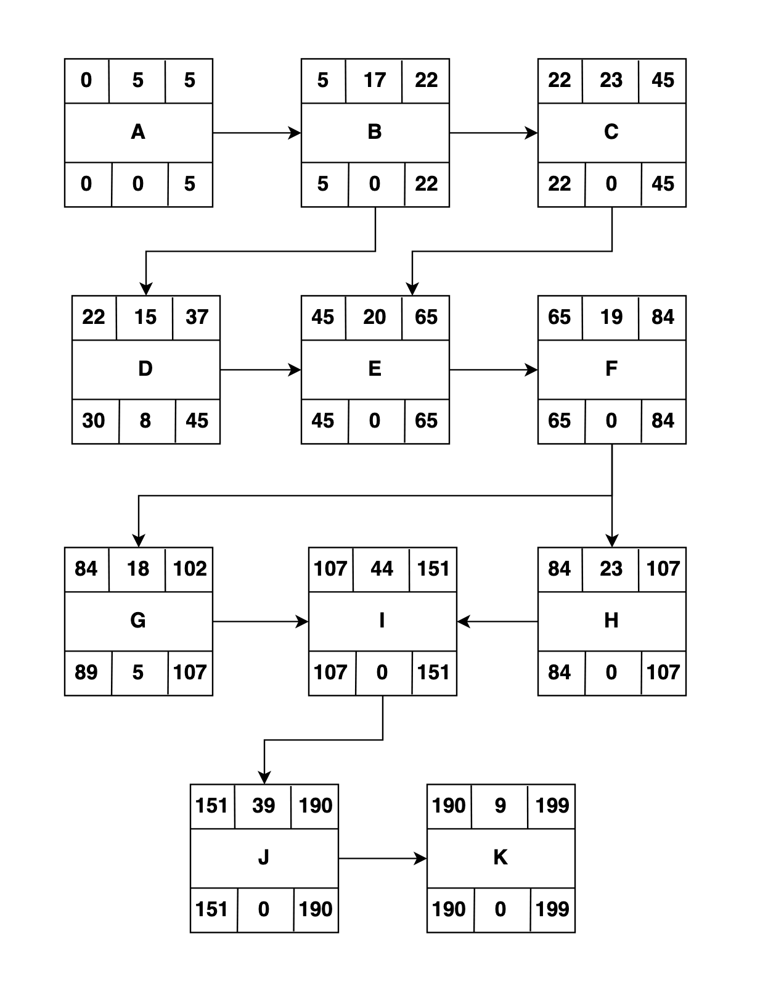
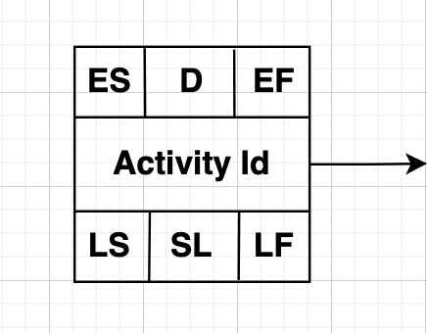
ES = Earliest Start EF = Earliest Finish
D = Duration (Days) LS = Latest Start
SL = Slack LF = Latest Finish
CPM:
EF = ES + D SL = LF - EF
LS = LF - D

Fig 2.2: Gantt chart

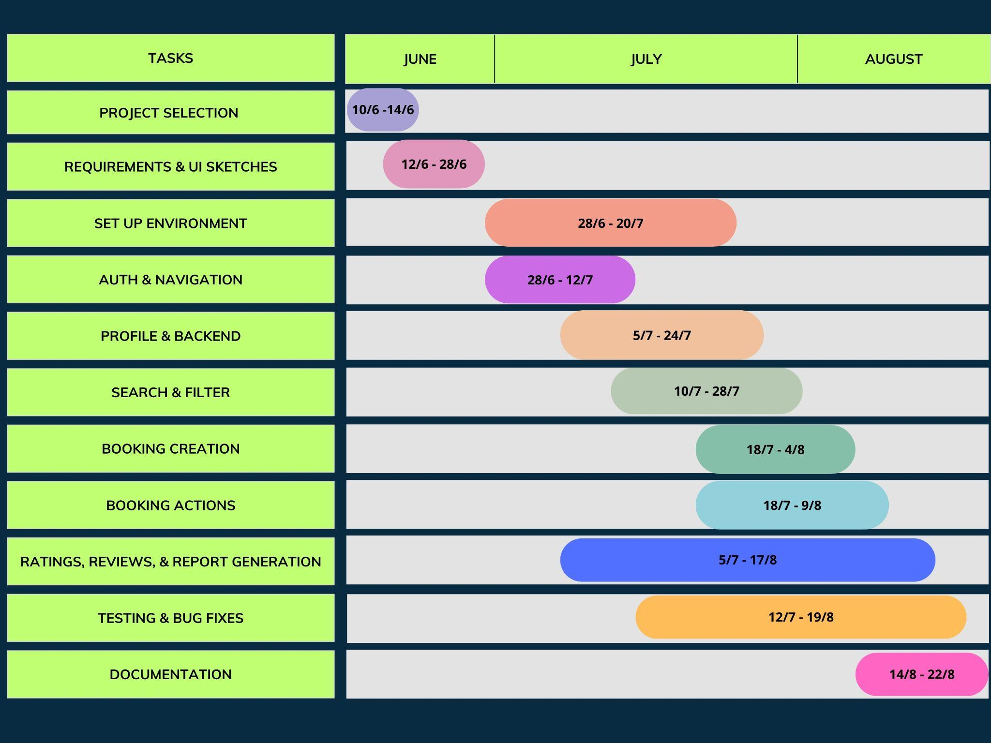
Start date – 10/ 06 /2025
Finish date – 22/ 08/ 2025.
Total Project Duration was 72 days approximately.

2.2.2 Risk Management
Risk refers to the uncertainty around the possible occurrence of an event or condition that can negatively impact our project's goals. Our project's risks include technical, operational, financial, legal, and personnel factors. These risks go beyond just missing physical components, as in hardware projects. They also include problems like dependency failures, unexpected cloud costs, data security breaches, and disruptions to team productivity. We have identified the most likely risks to this project, examined how they could delay or undermine its outcomes, and created mitigation strategies and a backup plan to reduce their impact.
Dependency and Component Unavailability: For a software prototype, third-party libraries, SDKs, or cloud services, such as a Flutter package, a Firebase feature, or a payment gateway API, might change, become outdated, or be temporarily unavailable. Additionally, shortages or delays in getting testing devices, like Android phones or iOS devices, can hinder validation on actual hardware. If a critical package is removed or rate limits restrict a cloud feature, the functionality that relies on that element may break and require rework.
Cost risk: A related financial risk comes from sudden increases in cloud usage or extra tool costs. Firebase provides a substantial free tier suitable for developing an initial prototype. However, real user trials or extended continuous integration processes can result in charges in billable tiers. Licensing fees for design, CI/CD tools, or notable SDKs can also add up.
Technical risks: Several technical risks are expected as well. These include integration errors between the Flutter frontend and the Firestore backend, race conditions in asynchronous processes, such as when bookings are created and immediately accessed, memory leaks from poorly managed streams or subscriptions, and incorrectly set Firestore security rules that may weaken data security. These technical issues could cause unpredictable behaviour, data loss, or security vulnerabilities.
Financial and personnel risks: Financial and personnel risks show the human side of student projects. Team members may get sick, face family emergencies, or experience financial troubles that affect their participation. These situations can slow down progress and create individual bottlenecks.
Mitigations: For each identified risk, we have specific strategies for mitigation. When dependencies are unstable, we will keep backup implementations and flexible interfaces to simplify library replacement. To tackle potential shortages of devices or hardware, we will improve the use of emulators and make reservations for on-campus resources. We will monitor usage, limit non-essential continuous integration tasks, and seek small sponsorships for unavoidable costs to manage cost-related challenges. We will quickly identify and fix technical issues through testing, conduct code reviews, and use the Firebase Emulator Suite to validate rules and functions. We will reassign tasks and narrow the project scope to address personnel shortages while ensuring that all artefacts are backed up in a shared GitHub repository to preserve progress.
Contingency Plan: Our backup plan recognises we cannot entirely remove all risks through mitigation. If a dependency fails, we will switch to the alternative module and reschedule the affected feature for later development. If unexpected increases in cloud costs occur, we will stop non-essential tests, reduce logging detail, and, when possible, move resource-heavy tests to the local emulator. If team members become temporarily unavailable due to health issues, we will adjust the schedule and redistribute tasks. We will postpone lower-priority features like advanced search, payment integration, and the provider dashboard, focusing instead on completing the core product. In cases of significant operational challenges like extended campus closures, the team will work entirely remotely, improve asynchronous documentation, and increase the frequency of check-ins for better coordination. All source code, design files, and data exports will be regularly backed up to GitHub and an off-site storage facility to ensure quick recovery.

2.2.3 Budget
The development of the GhorerKaaj Handyman Services App primarily required software resources that are open-source or free for academic use, along with standard hardware resources (laptops and smartphones), which were already available to us. Hence, no direct financial cost was incurred during implementation. The following table summarises the resource allocation and costs.

Table 2.2: Budget

Equipment / Resources | Cost (BDT)
Flutter SDK & Dart Language | 0
Firebase Console (Auth, Firestore, FCM – free tier) | 0
Firebase Emulator Suite | 0
Android Studio / VS Code (IDE) | 0
GitHub (Version Control) | 0
Figma / Adobe XD (free/student plan) | 0
Laptops/PCs (already owned by team) | 0
Android smartphones (for testing, already owned) | 0
iOS devices (if available, already owned) | 0
Internet connectivity (existing personal use) | 0
Miscellaneous costs | 0

2.3 Impacts of the Project

2.3.1 Sustainability over the product lifecycle

Sustainability can be evaluated across the usual lifecycle stages of a product: development, deployment, operation, maintenance, evolution, and end-of-life. We look at each stage's key environmental, social, and economic impacts. We identify the challenges and risks and recommend suitable strategies to reduce them.

Development
Sustainability depends mainly on using human and computing resources in the development stage. The chosen technology stack, including Flutter for the cross-platform user interface, Firebase for backend services, and SQLite for local data caching, reduces engineering duplication. This means only one codebase is needed for Android and iOS, improving economic and labour outcomes compared to managing two separate native applications. However, frequent local and CI builds, simulator runs, and automated testing cycles can lead to high energy consumption at workstations and CI. Poorly managed dependencies can cause redundant integration work and wasted developer time. To lessen these effects, the project should establish clear development guidelines. This includes a modular design that separates presentation, domain, and data layers; a well-documented branching and CI policy that schedules heavy builds, sets branch filters, and caches artefacts; and straightforward onboarding and contribution guidelines. These strategies will reduce repetitive tasks, speed up developer onboarding, and reduce carbon and monetary costs linked to prolonged development timelines.

Deployment
During deployment and hosting, the main sustainability factors are cloud resource efficiency, geographical location, and the amount of data transfer. Using Firebase makes operational tasks easier, with managed scaling, built-in authentication, and messaging, but it also creates hidden consumption patterns. Frequent real-time listeners, high read/write operations, and many calls to serverless functions increase cloud energy use and operating costs. The size of the application binary and how often updates occur also affect users' energy consumption during downloads and their data costs. To tackle these issues, the deployment strategy should focus on effective data modelling, such as minimising unnecessary reads and using indexed or denormalised structures when appropriate. Batch or schedule non-urgent write operations, and enable code shrinking or tree-shaking to reduce binary size. Choose hosting regions close to the target user base and select managed services encouraging efficient resource use. These actions will help cut ongoing cloud costs and lessen the environmental impact of scaling the service.

Operation
Operational sustainability looks at the effects on mobile battery life, network usage, accessibility, privacy, and the app’s broader societal impact. Continuous background location tracking, too many push notifications, or large uncompressed media downloads can increase users' energy use and data costs. Poor privacy measures can damage user trust and harm long-term engagement. Adopting an offline-first approach with a solid SQLite cache, incremental synchronisation, and careful use of background processes can significantly reduce network demands and battery use. Limit push notifications to essential events and group them when possible. Image assets should be served responsively, adjusted for device density, and optimised for compression. From a societal perspective, addressing issues like accessibility—such as screen-reader labels, colour contrast, and scalable fonts—and supporting multiple languages and having clear, privacy-focused data policies will promote inclusivity and lower barriers to adoption, improving the app’s social sustainability.

Maintenance and Evolution
The lifespan of a product depends heavily on how easy it is to maintain. An neglected codebase or unchecked dependencies can lead to repeated rework, security patches, and urgent fixes. This increases both labour and hosting costs. The project should use automated testing, including unit, integration, and smoke tests, to reduce this risk. It should also keep a regular release schedule with a long-term support (LTS) branch for urgent fixes. Additionally, dependency update tools, like Dependabot or similar options, should be used alongside a review process to prevent disruptive upgrades. Good documentation—covering architecture, everyday operational tasks, and incident response procedures—combined with reasonable test coverage goals for key modules, will help reduce mean time to repair (MTTR) and lower overall ownership costs.

End-of-life / Decommissioning
Carrying out a well-planned decommissioning strategy helps prevent orphaned data and extra cloud expenses. The retirement process should involve clear communication with users, options for data export in formats like CSV or JSON, and procedures for account deletions that remove personal data according to the privacy policy. It should also include a checklist for infrastructure teardown, which covers exporting or keeping legal records, revoking access keys, deleting backups, and ending cloud projects. If demo or prototype hardware is used for outreach, safe disposal or recycling should be provided. A clear decommissioning plan reduces legal, environmental, and financial risks as the project wraps up.

Materials and Resource Considerations
While the project's primary focus is software, the real environmental impacts mostly come from energy use during development, continuous integration, cloud hosting, and device usage—not material extraction. From an economic view, using a cross-platform approach reduces redundant development costs. Socially, being mindful of accessibility, privacy, and localisation boosts inclusivity and adoption. The key trade-offs involve finding a balance between convenience, frequent real-time updates, aggressive caching, and resource efficiency. All architectural choices should be supported by their cost and environmental impacts.

2.3.2 Impacts on society

On-demand service platforms improve access to affordable and timely home maintenance and repair services, especially in cities where travel time and transaction costs can be high. By connecting supply and demand, these platforms reduce the search effort for consumers. They can improve the use of local skilled labour, creating new earning opportunities for micro-entrepreneurs and informal workers. Studies of digital platforms and the gig economy show that participation in these platforms often provides flexible extra income for youth and women while lowering entry barriers for small service providers.

For handypersons and small contractors, platforms can increase order volume and stabilise weekly earnings through better visibility. They also make invoicing and ratings easier, which helps build customer trust. Research on home service applications suggests that local platforms promote micro-entrepreneurship and allow for faster matching of skills to demand, which is crucial in rapidly growing cities. At the city level, increased use may lead to formalisation, such as better record-keeping and tax compliance, especially if training and incentives are provided [11].

Digital platforms do not automatically ensure inclusivity. Access depends on smartphone ownership, digital skills, and affordable data; women and low-income groups often face greater barriers to participation as users and service providers due to costs, safety concerns, and societal norms. Global reviews show that the gig economy primarily attracts youth but still experiences ongoing gender and connectivity gaps. Closing these gaps requires intentional design, such as support in local languages, low-data user interfaces, and safety features. In Bangladesh, platform work can create financial opportunities for youth but also shifts risk to workers through irregular hours and limited social protections, which policymakers and platform operators must consider.

Reputational mechanisms like ratings and reviews, identity verification, and conflict resolution are key for building trust in home-service markets. Without strong verification and complaint resolution systems, customers risk facing poor-quality or unsafe work, while workers might deal with false complaints or payment disputes. Weak security and privacy in mobile apps, such as poor data protection or insecure payment systems, can undermine trust and leave vulnerable users out. Evaluations of digital service applications emphasise that good technical security and transparent governance are crucial for keeping users engaged.

Work done through platforms can increase worker risk when classified as independent contracting without benefits like sick leave or insurance. Studies on gig work highlight the dangers of low job protections and algorithmic control, which restrict workers' autonomy over scheduling and pricing. Similar problems may occur in local handyperson markets if poorly designed platform rules and commission structures are used. In Bangladesh and similar markets, the ongoing risk shift from companies to individual workers remains a significant issue.

Providing services that require home visits raises safety and gender-related concerns for clients and service providers, as inviting strangers into homes can lead to harassment. Female customers and service providers may be particularly concerned about safety and privacy. Including verified IDs, in-app emergency contacts, daytime-only services, and options for chaperones or dual-verification can help address these issues. Research on gender and digital access suggests affordable data and culturally relevant user experiences are essential for increasing women's participation.

High mobile data costs, limited smartphone access, and low digital literacy create barriers for lower-income groups. Studies of digital participation emphasise the need for low-bandwidth options, SMS/USSD fallback systems, and easy onboarding processes to avoid excluding the users the app aims to serve. The app risks benefiting mainly urban, well-connected users and service providers without such measures.

The widespread use of platforms interacts with local labour, tax, and consumer protection laws. Local authorities may need to update licensing, safety, and tax regulations to fit platform services. Working with city councils and trade groups can turn short trials into lasting benefits, such as training, certification, and insurance options. Studies on platform impact show that early communication with regulators is key to setting up rules that protect workers and encourage innovation.

Summary of stakeholder expectations
- Users want affordable, reliable, safe services, transparent pricing, and easy-to-use experiences in their local languages.
- Service providers want steady demand, fair commissions, access to customer verification and conflict resolution, and training opportunities.
- Institutions look for measurable public benefits, like fewer local disputes, and compliance with local licensing and tax laws. These expectations match feedback from similar platform launches and should be confirmed locally through surveys and test projects.

Inclusive design: create simple app versions, support local languages, allow offline or low-data use, use SMS for booking, and reach out to attract lower-income and female providers.

Worker safeguards: set clear commission structures, offer dispute resolution options, establish optional insurance pools or micro-benefit programs, and build training and certification pathways to improve earnings and trust.

Safety measures: require ID verification, include in-app job tracking, provide partner verification badges, set scheduled booking times, and create an emergency contact or reporting system.
Data privacy and security: restrict data collection to what is essential, encrypt sensitive information, follow local data protection laws, offer a clear privacy policy, and perform regular security checks.

Engagement with regulators: consult local authorities on licensing, taxes, and safety; consider creating pilot agreements for gradual scaling.
There are some examples of monitoring indicators :
- The proportion of users from lower-income backgrounds and female users (inclusion).
- The average monthly income of active service providers and the percentage earning above a living wage (economic impact).
- The number and resolution rate of safety or complaint incidents per 1,000 bookings (trust and safety).
- The number of app failures or security incidents per quarter and the time to resolve them (technical trust).

2.3.3 Effects on the environment

Every project affects the environment, and a software project like the Handyman Services Finder App is no exception. While the app primarily acts as a digital platform rather than a physical product, it will create positive and negative environmental effects throughout its life. This includes its development, hosting, daily use on users' devices and networks, and finally, device disposal and electronic waste. The following discussion highlights the main benefits and drawbacks we expect. It then offers practical strategies to improve the positive aspects and reduce the negative ones.

Advantages:
To start, simplifying the process for customers to find, compare, and book local service providers can reduce unnecessary travel and the frequent in-person visits typical of on-the-spot service procurement. This includes making multiple trips to identify the right provider or collect quotes. Online booking and clearer scheduling help decrease unnecessary trips. They also allow providers to plan their visits more effectively, ultimately reducing transport-related emissions. Many studies and reviews show that using digital tools and delivering services remotely can lower carbon intensity in various sectors. Well-designed digital services significantly reduce emissions [7], [8].
Second, the application can improve resource use by reducing the need for paper and printed advertisements. It allows for electronic receipts and records and encourages small businesses to switch to digital processes. When adopted by many users and providers, these minor changes can lead to less material waste and lower paper consumption, physical advertising, and traditional record-keeping methods. Ultimately, the platform can promote eco-friendly choices directly, such as featuring providers that use electric vehicles, low-emission transportation, or sustainable materials. This approach enhances the app’s positive environmental impact through user nudges and transparency.

Disadvantages:
Digital services have their own environmental impacts. The application relies on cloud infrastructure for authentication, databases, messaging, network transmission, and user devices, all of which need energy. Data centres and transmission networks currently account for a large and growing share of global electricity use, and this trend will likely continue as demand for digital services increases. The energy consumed by servers, cooling systems, and network devices produces greenhouse gas emissions unless it comes from low-carbon electricity sources [9]. Mobile applications also affect how much energy users' devices consume. Regular network requests, heavy media use, and poor caching drain batteries and increase data transfer. This, in turn, leads to higher energy consumption in both devices and networks. Research shows that how apps are designed and used greatly influences the energy needs of devices and the volume of network traffic. Inefficient apps cause a bigger environmental impact from mobile usage [10].

Mitigation:
The environmental issues can be effectively managed through careful design and operational strategies. We aim to reduce the app's carbon footprint for infrastructure by selecting cloud regions and providers with firm sustainability commitments. We also choose those that use low-carbon electricity whenever we can. Leading cloud providers now offer carbon tracking and the option to host workloads in areas with lower carbon emissions. Moving non-urgent batch jobs and testing tasks to these regions helps lower the emissions from hosting. In application development, we will focus on designing for energy efficiency. We will minimise unnecessary network requests, use effective caching strategies, compress data payloads, avoid constant background polling, and use lightweight media whenever possible. These strategies will lower battery use on devices and reduce network traffic. This, in turn, will decrease the energy footprint for each user session. Additionally, we will include app telemetry, with proper privacy protections, to identify and improve energy-heavy processes before their full release [10].
To address e-waste concerns, the initiative will offer user-friendly guidance encouraging device recycling and responsible upgrades. During pilot programs, we will also work with campus or local electronics recycling campaigns. When we provide devices for testing, we will ensure they are either reused or recycled properly at the end of the project. Additionally, by keeping the app efficient and compatible with older versions, we can extend the lifespan of older devices and reduce the need for unnecessary upgrades. This is a small but meaningful step toward cutting down e-waste [12].

2.3.4 Health and Safety issues
Health and safety planning is important because digital bookings lead to in-person work at customer sites. Field activities, such as repairs, electrical and plumbing work, and travel, carry certain risks. Technical tasks pose risks, including device lab work, development activities, and data-related incidents. Risks associated with field operations. Field work by handypersons introduces a range of hazards that can cause injury to service-providers, customers, or third parties. Principal risks include: Physical injury from tools, ladders, sharp objects, hot surfaces, and live electrical circuits during repair tasks. Exposure to hazardous materials (chemicals, solvents, asbestos in old buildings) during certain repairs. Work at height (roofing, tall ladders) and manual handling (lifting heavy objects) cause falls and musculoskeletal injury. Infectious disease transmission (e.g., respiratory illnesses) occurs from close contact during house calls. Personal security risks for workers entering unfamiliar or poorly screened locations (harassment, robbery). Mitigation measures (field operations) Mandatory basic safety training for all registered providers: safe tool use, electrical isolation procedures, ladder safety, manual handling technique, and basic first aid. Training certificates should be recorded in provider profiles. Job categorisation & capability matching: classify bookings by risk level (low/medium/high) and require explicit provider qualifications/certifications for higher-risk jobs (e.g., electrical, gas). The app must block unqualified providers from accepting high-risk jobs. Pre-job safety checklist: include an in-app checklist that the provider ticks before starting (e.g., PPE available, power isolated, permit/consent obtained). Completed checklists are logged with the job record. Personal Protective Equipment (PPE): requires the use of appropriate PPE (gloves, goggles, insulated tools) and offers guidance on PPE selection for each task type. The platform can recommend local suppliers or include guidance in onboarding. Emergency & escalation procedures: in-app “panic/SOS” for providers and customers, and a rapid response contact (phone/email) maintained by the platform for serious incidents. Insurance & liability: promote or facilitate personal accident and public liability insurance for providers; clearly display liability rules and insurance cover options in provider onboarding and terms of service. Safe scheduling & daylight preference: encourage scheduled visits in daylight hours for higher-risk tasks, and support customer options to require two-person attendance for certain jobs. Hazard communication: Enable customers to mark site hazards (pets, wet floors, chemicals) in booking details and require providers to acknowledge such warnings before arrival. B. Electrical, gas and specialist work. Certain jobs (electrical wiring, gas appliance repair) carry an acute risk of serious injury or property damage. Mitigation measures (specialist work): Enforce documentary proof of licensure/certification for regulated tasks; integrate a verification step in provider profiles. Electrical/gas jobs require providers to follow isolation and testing protocols (voltage testers, lockout/tagout) and record these actions in the job log. Licensed trades require higher insurance minimums and permit documentation where relevant. C. Personal security and customer safety Risks to customers and workers arise from a lack of identity verification and poor vetting. Mitigation measures (security & trust) Verification: mandatory identity verification for providers (government ID or equivalent) and optional verification badges for customers (to reduce no-show/abuse). Ratings & referrals: use rating histories, repeat customer data, and community referrals to surface trustworthy providers. Two-factor identification for higher-risk visits: require a photo ID check on arrival for certain categories or high-value jobs. Payment safeguards: use in-app secure payments and hold funds in escrow until job completion to reduce disputes and risky cash exchanges. D. Infectious disease & public-health measures. Given the possibility of contagious illnesses, the platform must reduce transmission risk for workers and customers. Mitigation measures (public health:) Provide clear guidelines for hygienic practice (masking policy during high transmissibility periods, hand hygiene, surface cleaning). Support contactless workflows: contactless check-in/out, digital signatures, and photo evidence of completion to reduce close interaction. Allow temporary suspension or rescheduling of jobs when a provider or customer reports infectious symptoms; record such events for contact tracing if local law requires. E. Technical/developer & device testing safety Testing and development activities also present safety and operational risks when hardware emulators and physical devices are used. Mitigation measures (technical testing): Use Firebase Emulator Suite and virtual emulators for as much testing as possible to avoid unnecessary use of physical devices. Where physical devices are required (Android phones, iOS devices), maintain a charging and battery-care policy to avoid battery overheating; only use certified chargers and avoid unattended charging. Maintain a controlled testing environment for device labs (adequate ventilation, tidy cabling, surge protection) and enforce ergonomics and workstation breaks for developers. Use up-to-date antivirus and device management practices on test devices to avoid malware and data leaks during testing. F. Data privacy, information security and cyber-safety. A breach of customer or provider data can create reputational harm and, in some cases, physical risk (exposed home addresses, schedules). Mitigation measures (cyber-safety): Implement strong authentication (Firebase Authentication, option for multi-factor where feasible) and least-privilege access to logs and personal data. Minimise data collection and avoid storing sensitive location or home access details unless strictly necessary; whenever stored, encrypt sensitive fields at rest and in transit. Maintain audit logs for bookings and access to provider/customer personal data; notify affected users promptly in accordance with local regulations in case of breaches. Train staff and developers in secure coding practices and conduct periodic security audits/penetration tests. G. Operational controls, training and documentation. Sustained safety performance requires processes and record-keeping: Onboarding & periodic refresher training for all providers covering safety, first aid, customer interaction and platform policies. Training completion status must be visible on provider profiles. Standard Operating Procedures (SOPs) and runbooks for high-risk activities (electrical isolation, gas work, ladder use, infection control). Incident reporting & investigation process: every accident or near-miss is logged, investigated, and followed by corrective action and communication to the provider network. Safety audit program: periodic audits of provider performance, user complaints, and PPE and insurance documentation verification. H. Resources linkage (operationalising mitigations) The project’s listed software and hardware resources should be leveraged to support safety measures: Flutter & Firebase Authentication: implement verified sign-ups, role-based access, and secure login. Use Firestore to store training certificates, verification documents, and safety checklists with proper security rules. Firebase Cloud Messaging: send safety alerts, training reminders, and incident notifications to providers. Firebase Emulator Suite & GitHub: test safety flows and emergency features in emulated environments before release; keep change history and rollback points in GitHub. Android/iOS test devices & emulators: test the SOS flow, checklists, and contactless completion photos in controlled device labs using the safety procedures above. Figma/Adobe XD: prototype clear, unambiguous UX for safety steps (pre-job checklists, hazard declaration) to reduce human error. I. Monitoring indicators and targets. To measure safety performance, the platform should track a concise set of KPIs and targets: Number of reportable incidents per 1,000 bookings (target: < X — benchmark from pilot). Proportion of active providers with up-to-date safety training and valid insurance (target: 100% for high-risk categories; ≥ 80% overall). Average response time to SOS/emergency events (target: < 30 minutes for escalation). Share of bookings with completed pre-job safety checklist (target: ≥ 95%). Number of data-security incidents per year and mean time to remediate (target: zero major breaches; MTTR < 7 days). J. Legal, liability and consumer protection. Clear terms and insurance expectations reduce disputes and set safety norms: Publish transparent terms of service that explain provider/customer responsibilities and liability limits. Where the law requires, record and present provider licences and permits; cooperate with regulators when incidents implicate public safety. Consider providing or brokering access to group insurance schemes for providers (affordable accident and liability cover).

PART - B
3. Project Design

3.1 Design process
The development of GhorerKaaj followed a user‑centred design process that translated high‑level requirements into a working app. We began by exploring existing on‑demand home‑services platforms and interviewing a handful of potential customers and tradespeople to understand what features would make a local service marketplace genuinely useful. Common pain points – such as difficulty finding trustworthy professionals, poor communication, and a lack of transparency around pricing and scheduling – helped us define the essential features: secure account creation, detailed provider profiles, a robust booking system, and ratings and reviews.
With these requirements in mind, we sketched user journeys to visualise how household customers and handypersons would move through the app. These flows informed the information architecture and allowed us to map out individual screens for sign‑up/login, searching for services, booking a job, reviewing a job, and managing orders. We refined our ideas through wireframes created in Figma. These mock‑ups were shared with classmates and potential users for feedback, which led to improvements such as clearer navigation, streamlined booking forms, and prominent placement of ratings.
Once the overall user experience was agreed upon, we selected the technologies for implementation. Flutter was chosen for the front‑end to allow a single code‑base across Android and iOS, while Firebase provided user authentication, a cloud‑hosted NoSQL database, and push‑notification capabilities. We then designed the database schema, defining collections for users, service providers and bookings that would support efficient querying and filtering. Throughout development we adhered to Material Design guidelines to ensure a consistent look and feel, and followed modular coding practices so that individual components (authentication, booking, reviews, notifications) could be developed and tested independently.
Early iterations of the design were implemented and tested on emulators and physical devices. Feedback from these tests guided further refinements, such as adding an offline cache for previously viewed listings and improving the accessibility of forms and buttons. Each sprint ended with a review of progress against the design goals, ensuring that the evolving prototype remained aligned with user needs.

3.1.1 Considerations while developing the design
The design phase for GhorerKaaj balanced functional requirements (bookings, profiles, search, notifications) with a set of cross-cutting constraints and non-functional requirements imposed by the chosen technology stack (Flutter, Firebase, SQLite), the target platforms (Android and iOS), and the operating context (low-bandwidth/mobile users, informal service market).

I. Platform and technology constraints:
- Cross-platform (Flutter): one codebase for Android/iOS; plugins kept stable and platform code isolated.
- Backend (Firebase): handles auth, data, and notifications; schemas optimised for reads with secure access rules.
- Local cache (SQLite): offline-first sync with conflict handling and queue management.

II. Functional & user-flow considerations:
- Core flows: sign-up, search, booking lifecycle, notifications, ratings; screens designed for minimal taps.
- Progressive enhancement: lightweight mode for low bandwidth; lazy loading for assets.
- Safety & trust: provider verification, hazard flags, SOS/report features built into profiles and bookings.

III. Non-functional requirements (NFRs):
- Performance: minimise background work, rely on event-driven updates.
- Offline resilience: cached listings, reliable booking queue with sync status.
- Scalability: denormalised data, batched writes, usage monitoring.
- Security & privacy: Firebase Auth + Firestore rules, TLS encryption, account deletion/data export.
- Accessibility & localisation: scalable fonts, high contrast, screen-reader labels, Bangla/English.

IV. Architectural & code quality considerations:
- Modularity: UI, domain, and data layers separated; state management with Provider/Riverpod/BLoC.
- Testing & CI: automated unit/integration/UI tests; Firebase Emulator Suite in CI.
- Dependencies & releases: pinned versions, semantic versioning, small APK target.

V. Operational & deployment considerations:
- Secrets: keys managed via CI secrets; setup documented.
- Monitoring: analytics, crash reports, KPIs (e.g., booking success, sync failure).
- Packaging: reproducible APKs, iOS guidance, demo scripts for instructors.

VI. Constraints, assumptions and trade-offs:
- Convenience vs efficiency: balance real-time updates with cloud cost and battery.
- Device diversity: test across Android versions and limited iOS devices.
- Regulatory: safety, worker protections and local compliance in provider workflows.

VII. Measurable design targets:
- APK size ≤ 30 MB.
- 30% fewer DB reads/session after caching.
- ≥ 70% automated test coverage for core modules.
- ≥ 95% offline booking sync success.
- < 2s booking action response time.

3.1.2 Developing design process

The GhorerKaaj design approach followed a systematic and iterative method to ensure the final product met user needs, technical requirements, and project deadlines. The process combined structured planning with flexible adjustments based on testing and feedback. The main phases are outlined in the steps below:

1. Requirement Analysis and Conceptualization :
The team started by discussing the project's scope, goals, and deliverables as described in the course outline. They gathered requirements from both household users and service providers. This phase included early sketches of the user interface, created in Figma, to show the app’s key features like signup/login, handyman profiles, booking processes, and notifications.

2. Technology Selection and Setup :
The design adhered to the limitations set in the README, using the Flutter SDK for cross-platform development and Firebase for services such as authentication, databases, and notifications. SQLite was chosen for offline data caching. Version control was managed with GitHub, and Android Studio and VS Code served as the main development environments. These choices influenced the modular architecture, making it easier to maintain and scale.

3. Architectural Planning:
The codebase was structured into different layers:

- UI Layer for screens and user interactions,
- Domain Layer for business logic,
- Data Layer for integration with Firebase and SQLite.

This separation, supported by state management tools like Provider/Riverpod, improved testability and reduced interdependencies. During this phase, the team created system diagrams and flowcharts to clarify module dependencies and user journeys.

4. Iterative Prototyping and UI/UX Design:
Using Figma mock-ups, the team improved the visual design and navigation patterns. They incorporated accessibility principles (like contrast, font scaling, and screen reader compatibility) and bilingual features (Bangla/English). Prototype screens were tested among peers to gather feedback on the clarity and usability of the flow. Adjustments were made iteratively before implementation.

5. Development and Integration:
The team-built core functionalities step by step according to the activity chart and milestones: authentication, profile creation, search and filtering, booking flows, notifications, and rating system. Each feature was tested individually before integration. The Firebase Emulator Suite simulated authentication, database transactions, and notifications during development, reducing reliance on live services.

6. Testing and Refinement:
In the final design stage, the team conducted integration testing, usability evaluations, and bug fixes. This ensured that offline booking synchronization worked reliably, push notifications were consistently received, and security measures were properly enforced. They monitored test cases and recorded any outstanding issues for future improvements.

7. Documentation and Presentation:
Finally, the design process was documented in a project report that included diagrams, flowcharts, and reasons for design choices. The prototype was compiled into a functional APK, and a presentation was prepared and delivered on the scheduled date, 23 August 2025.

3.2 Analysis of alternate solutions

Client (mobile) — alternatives
- Native (Kotlin for Android / Swift for iOS)
  - Best performance, full access to native APIs, platform-specific UX.
  - Twice the implementation effort (two codebases), longer development time, higher maintenance.
  - Rejected for MVP due to time and resource constraints.
- React Native
  - Single codebase (JS), large ecosystem, fast for UI development.
  - Some native-module friction, varying performance for complex animations; team familiarity with Dart/Flutter may be lower/higher depending on members.
  - Considered viable but not chosen — Flutter provided preferred UI consistency and tooling for this team.
- Flutter (Chosen)
  - Single codebase for Android + iOS, fast UI iteration, expressive widgets, strong hot-reload & good community packages.
  - Larger binary size than minimal native project; some platform-specific edge cases require native code.
  - Best fit for rapid cross-platform development and consistent UI with limited manpower.

Backend / BaaS — alternatives
- Custom backend (Node.js + Express + Postgres / MongoDB)
  - Full control over data model, business logic and hosting; easier to migrate away from vendor lock-in.
  - Requires server development, deployment and maintenance; increases project scope and ops burden for a semester project.
  - Rejected for MVP due to extra development & ops overhead.
- Firebase (Chosen: Auth, Firestore, FCM)
  - Ready-to-use Authentication, real-time DB (Firestore), Cloud Messaging, minimal ops, fast integration with Flutter, strong documentation and community.
  - Some vendor lock-in and costs at scale; careful security rules required.
  - Enables rapid prototyping, low operational burden and built-in real-time/notification features required by booking flows.
- Supabase / AWS Amplify / Other BaaS
  - Supabase offers Postgres + realtime, Amplify integrates well with AWS services.
  - Less mature Flutter integrations (depending on feature), different learning curve, comparable vendor-lock issues.
  - Firebase chosen for maturity and available Flutter tooling.

Local persistence — alternatives
- No local cache
  - Simpler implementation.
  - Poor usability in intermittent networks; fails the offline-resilience objective.
  - Not acceptable for target users.
- SQLite (sqflite plugin) (Chosen)
  - Lightweight, proven on mobile, easy local queries and persistence for cached lists and queued bookings.
  - Requires schema & sync logic; conflict resolution needed.
  - Good balance of simplicity and reliability for offline queueing.
- Hive / SharedPreferences / Object stores
  - Hive is faster for simple key/object storage; SharedPreferences for tiny key-value.
  - Less suited for structured queryable caches or queued complex booking payloads.
  - Could be used for small caches but SQLite preferred for structured queued bookings.

Push notifications — alternatives
- Firebase Cloud Messaging (FCM) (Chosen)
  - Free for typical usage, direct integration with Firebase project, well supported on Android & iOS (via APNs).
  - Requires careful token management and platform setup (APNs for iOS).
  - Best fit with Firebase backend and Flutter ecosystem.
- Third-party services (OneSignal, Pusher Beams)
  - Higher-level features (segmentation, dashboards).
  - Extra dependency, possible cost, additional integration work.
  - Considered for the future if advanced features are needed.

3.3 Design and refinement

This section records how the initial design ideas were iterated into the final app design for the MVP. It describes key UI flows, data & sync behaviour, verification of assumptions through quick tests, and the refinements applied to improve usability, reliability and maintainability

- Initial design decisions (summary)
- Client: a single Flutter codebase for Android and iOS to keep the UI consistent and speed up development.
- Backend: Firebase (Auth, Firestore, FCM) to provide ready-made authentication, real-time data, and push messaging.

- Local persistence: SQLite (sqflite) to store the last-seen listings and queue bookings while offline.
- State management: a simple provider pattern for MVP. This keeps the code modular and easy to understand.
- UX focus: minimal onboarding, one-screen booking, clear status badges, and prominent trust signals like ratings and verification badges.

- Key UI flows (implemented and refined)

I. Onboarding / Auth
- Initial plan: require a complete profile at signup.
- Refinement: reduce friction by allowing minimal signup with just a name and phone/email. Users can complete their profile later.
- Rationale: this leads to faster user activation and reduces drop-off during demos and tests.

II. Browse → Profile → Book
- Flow: Service category leads to a list of handymen, then to their profile and a booking modal.
- Refinement: moved price, rating, and the main action (Book) above the fold on the profile screen so users can act quickly. Added a “recently viewed” row for quick access, using the SQLite cache.

III. Booking lifecycle
- Initial plan: a complex multi-step booking.
- Refinement: simplified to a single-screen booking that includes service, date/time picker, short notes, and an optional photo. Added clear labels for pending, accepted, in-progress, and completed statuses, along with push notifications for each transition to reduce confusion.

IV. Handyman actions
- Provided a compact handyman dashboard featuring an incoming requests list, quick accept/decline buttons, and a simple status change control (On-way, Start, Complete).
- Refinement: added confirmation prompts to avoid accidental accepts and a brief "how to use" tooltip for first-time handyman users.

- Data & synchronization refinements

I. Local caching strategy
- Design: cache the last few viewed handymen and store queued bookings in SQLite.
- Refinement: use timestamped entries with a simple last-write-wins sync policy. Show an “offline” banner and a “queued” badge on bookings to keep users informed.

II. Firestore data model adjustments
- Initial model used nested arrays for availability.
- Refinement: normalized availability into a small subcollection per handyman (availability/{date}) to make queries simpler and minimize document size and read costs.

III. Notifications
- Integrated FCM for booking events.
- Refinement: added local in-app fallbacks (local notifications) for situations when FCM token delivery is delayed. Ensured idempotent processing to avoid duplicate status updates.

- Usability & validation activities
- Quick user tests: Five informal testers performed key tasks like signup, browsing, booking, and accepting requests. Their feedback led to immediate fixes, such as clearer confirmation dialogs, larger tap targets on small screens, and improved error messages for offline booking.
- Performance checks: Measured cold start times and typical Firestore read latency on midrange devices. Optimized performance by reducing the initial data fetched at launch and deferring the loading of heavy profile images.
- Security checks: Reviewed basic Firestore rules to ensure that only owners can change their documents and that only authenticated users can create bookings.

- Visual & interaction refinements
- Adopted a card-based list for handymen with consistent icons and color-coded status badges.
- Improved contrast and font sizes to follow accessibility standards for readability on small screens.
- Added small animations like loading skeletons and success ticks to enhance perceived performance.

- Final design artifacts (deliverables)
- High-fidelity mockups (Figma) for all main screens: Home, Search, Profile, Booking, Handyman Dashboard, Notifications. A link is included in the deliverables.
- Firestore schema diagram and simplified ER mapping (Appendix B).
- SQLite schema and sync flow diagram (Appendix B).
- Short demo script and recorded walkthrough used for evaluation.

- Design trade-offs (concise)
- Choose simplicity and speed to MVP over exhaustive features like payments and advanced geo-matching.

- Accepted some vendor lock-in with Firebase to reduce operational burden and speed up implementation.
- Prioritized a clear, testable booking UX and offline resilience as the features with the most user value for the semester.

3.4 App Demonstration

Fig 3.1: GhorerKaaj App logo
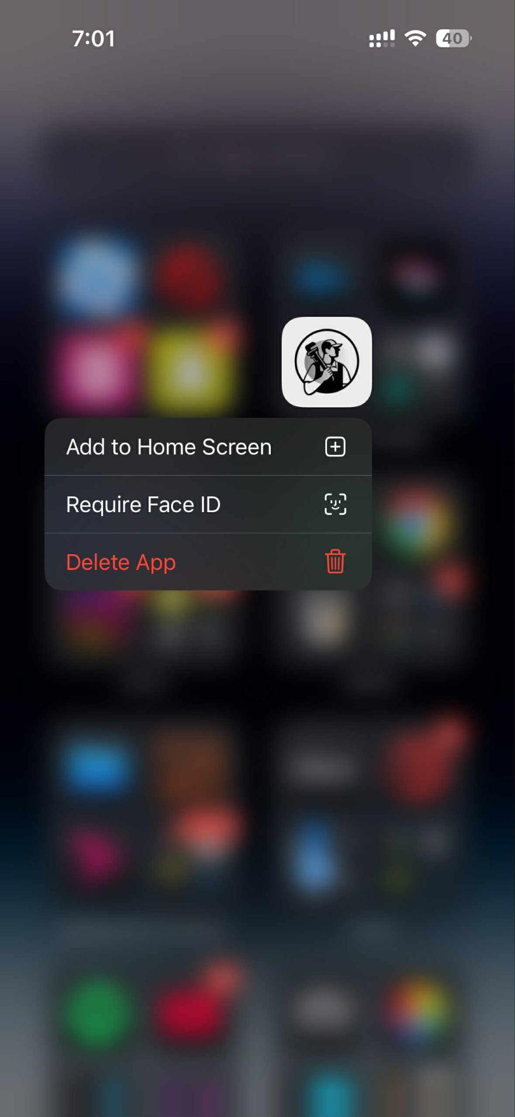

GhorerKaaj comes with its unique and modern app logo. At its centre is a man with a wrench, following a monochrome colour scheme, making the design minimalistic and highlighting its purpose.

Fig 3.2: Splash screen


Fig 3.2.1: Splash screen (zoomed-in)


The Splash Screen: This screen pops up at the opening of the application. It stays for 3 seconds, while the app loads, highlighting the brand name and motto and having the app logo work as the letter ‘O.

Fig 3.3: Sign-in page

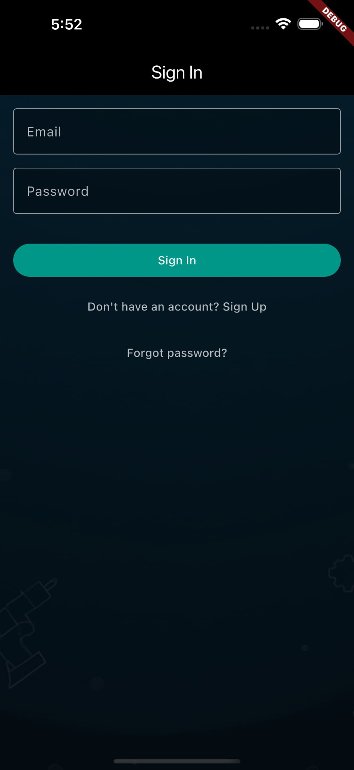

A new or logged-out user is taken to the ‘Sign In’ page, which has the option to enter their email or password. If the user already has an account and a matching email/ password in the database, the user will successfully log in by clicking the ‘Sign In’ button. Users can even create a new account by clicking on ‘Sign Up’ or reset their password by clicking on ‘Forgot password?’

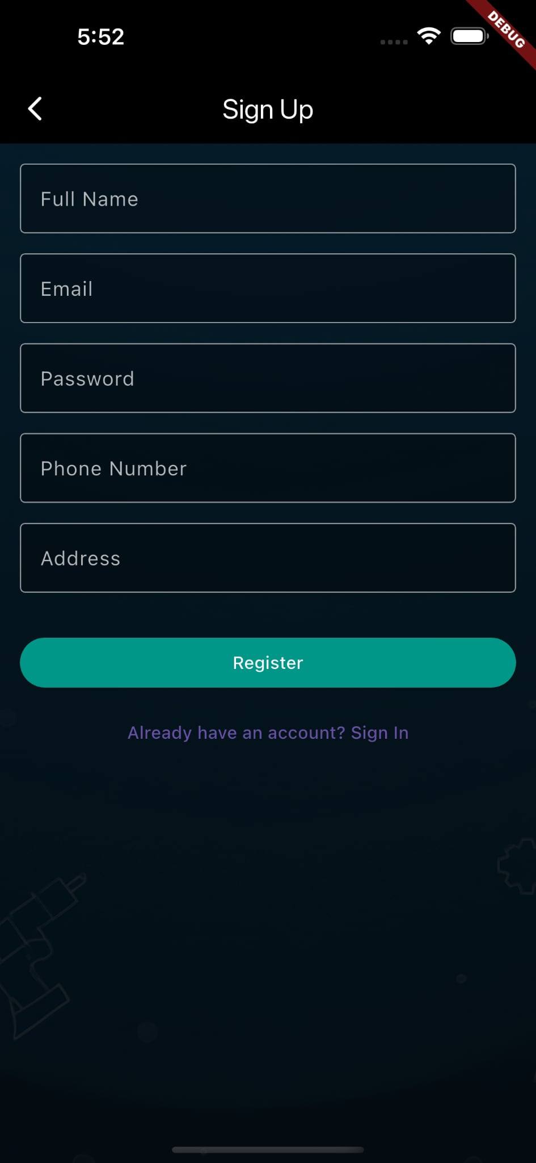
Fig 3.4: Sign-up page

Assuming the user is new and has clicked the ‘Sign Up’ button. The user is brought into the ‘Sign Up’ page, where he is asked to fill in the necessary information fields and register as a new user by clicking the ‘Register’ button. The user even has the option to go back if they already have an account by clicking on the button below ‘Register’.

Fig 3.5: Reset-password page
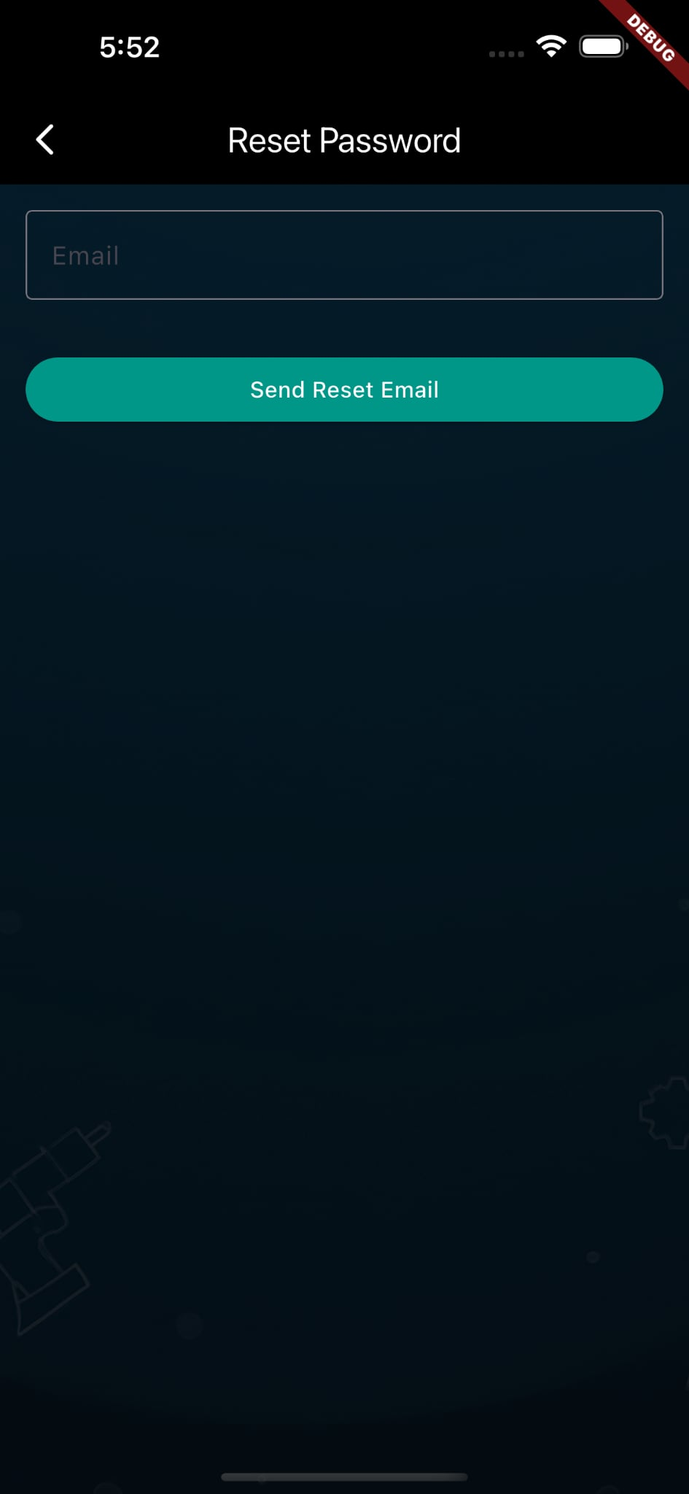

On the other hand, if the user had pressed on the ‘Forgot Password?’ button, the user would be redirected to the ‘Reset Password’ page, where, upon entering his correct email account and clicking the ‘Send Reset Email’ button, he would be sent an authentication email - with the link to reset his password in his email account.

Fig 3.6: My-profile page
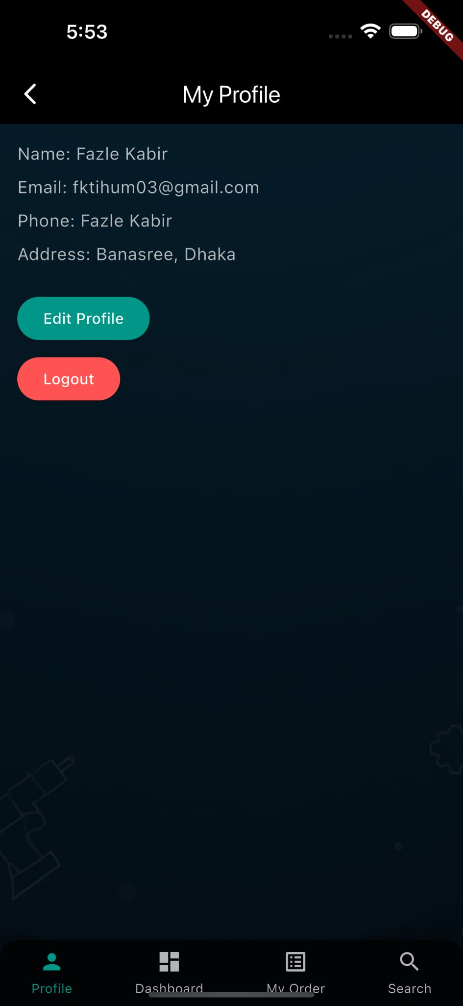


Fig 3.6.1: Navigation buttons
Once the user has successfully logged in, they can toggle between these four buttons at the bottom – currently in the ‘My Profile’ page, where they can view and edit their information and log out from the application.

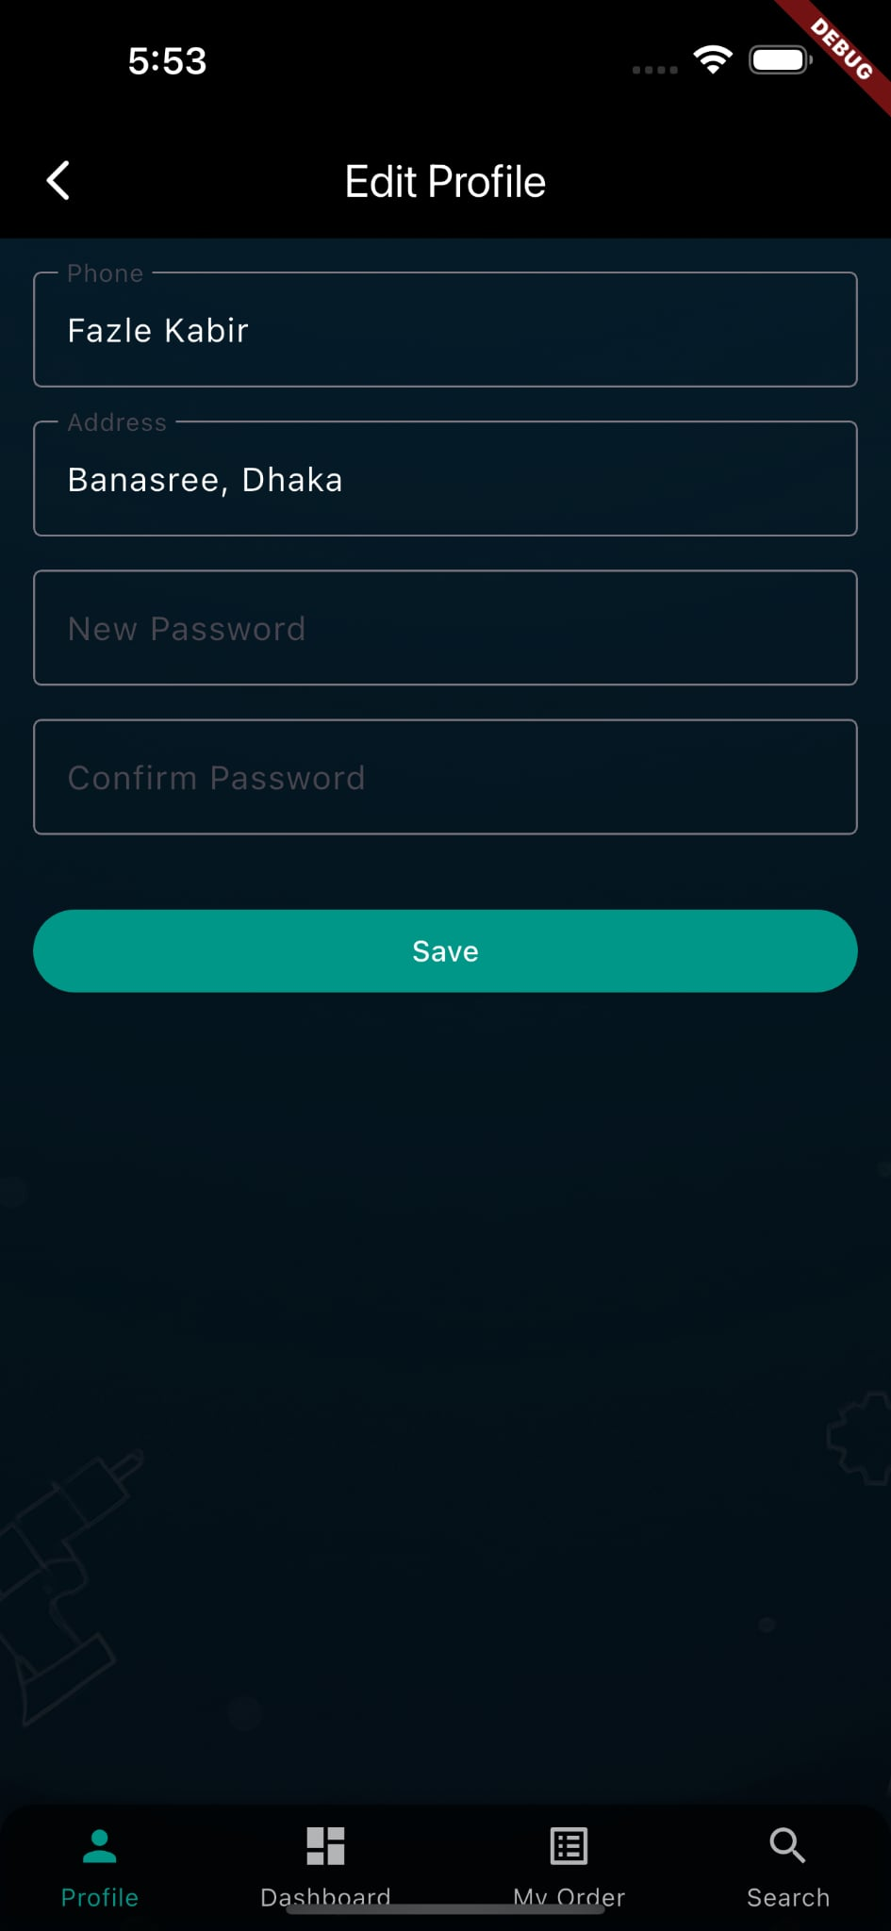 Fig 3.7: Edit-profile page
This is the ‘Edit Profile’ page. The updated information saved here will also update the user database.

Fig 3.8: Dashboard page
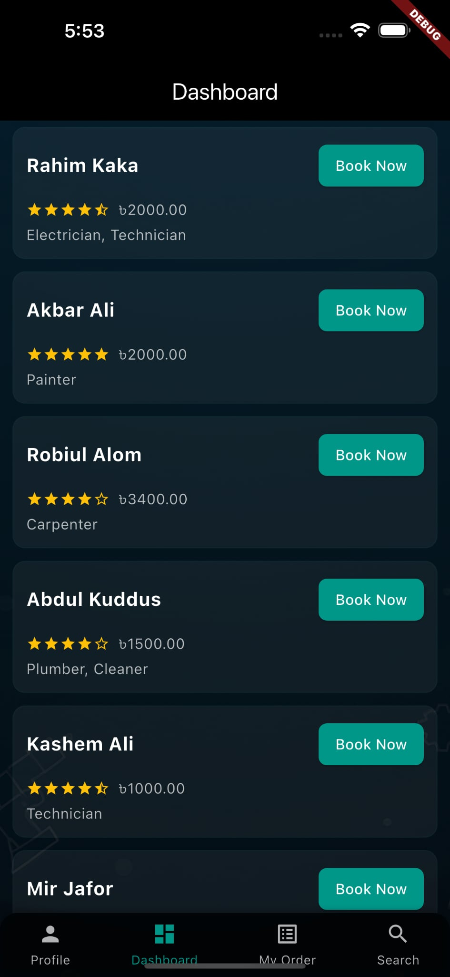

The user is currently on the ‘Dashboard’ page. This page shows an option to book handypersons, highlighting their certain information, i.e. Name, Rating, Price, and category. The user can directly book a handyperson here.

Fig 3.9: Handyman-profile details pop-up
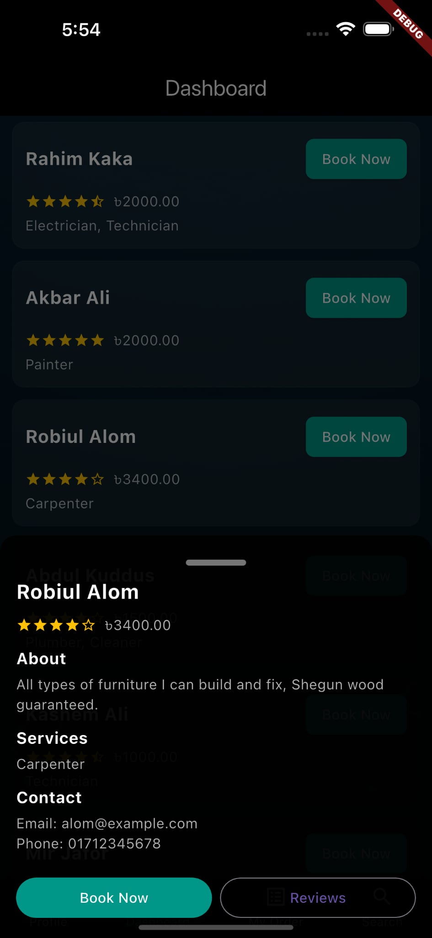

If the user clicks on a specific handyperson, the page will pop up with the handyman’s detailed profile information and the option to read user reviews.

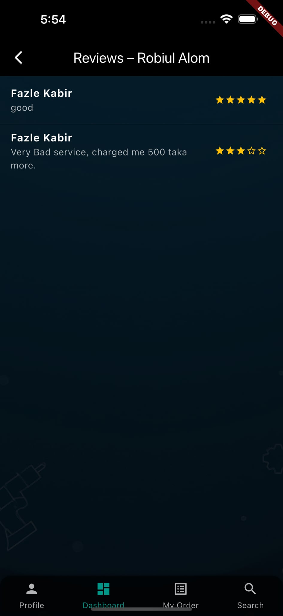 Fig 3.10: Reviews page

It shows multiple reviews from the same user because the app is in the testing phase. However, a user can only write one review at a time and, upon any future purchases/ calls, can write a new review, which will update the previous one. In short, only one review from a user will be highlighted on the ‘Reviews’ page.

Fig 3.11: My-orders page
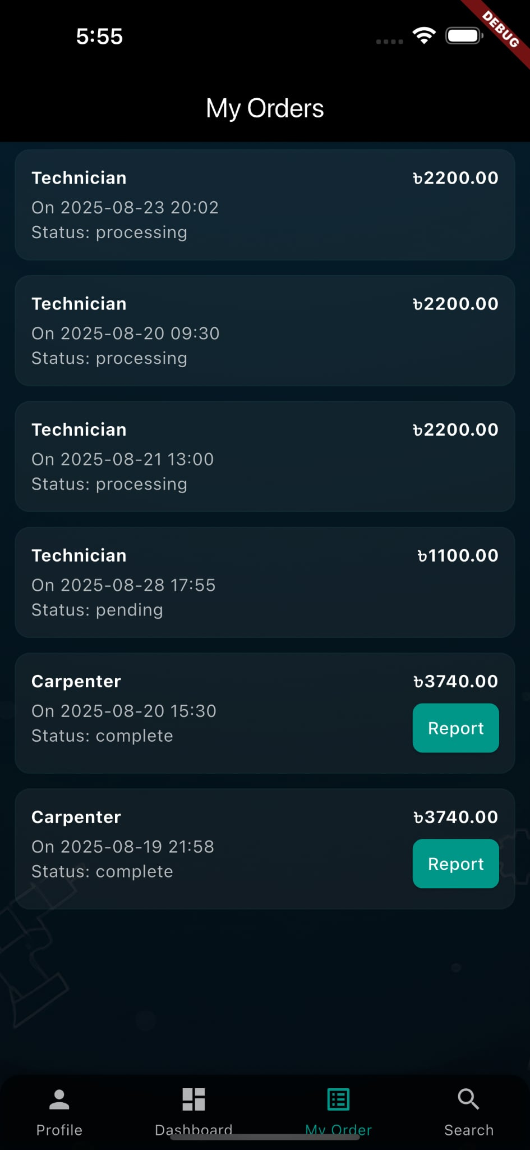

This page is the ‘My Orders’ page, which will display all orders the user has made. Orders that have been completed will go down the list – updating status as ‘complete’, orders in ‘pending’ state will stay in the middle, and the orders currently ‘processing’ will stay at the top.
The user also has to generate an order report.
The total cost being shown applies 10% app charges, which are added inclusively to the handyman’s cost.

Fig 3.12: Order-details page
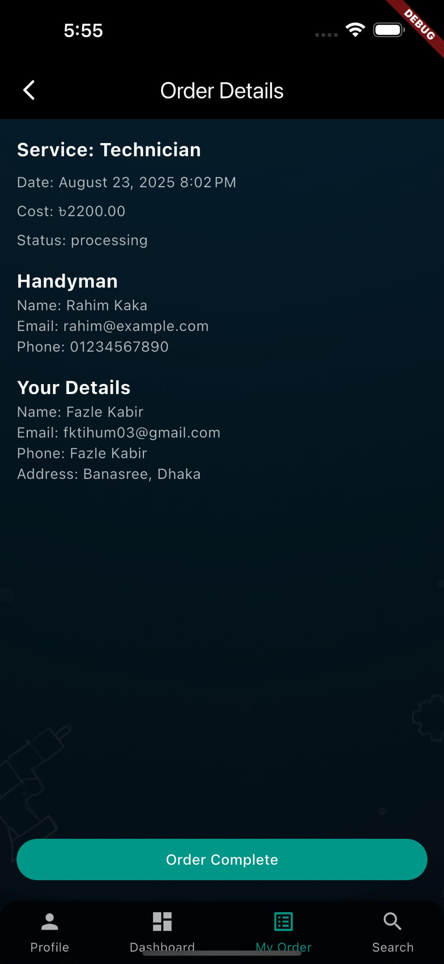

At present, the user has access to manually complete an order that is currently under the ‘processing’ state. This is due to the time constraints of developing the application. We have only created the user end for demonstration purposes, not the application's handypersons or admin end.
The user can ensure that the order has been completed by clicking on the' Order Complete' button.

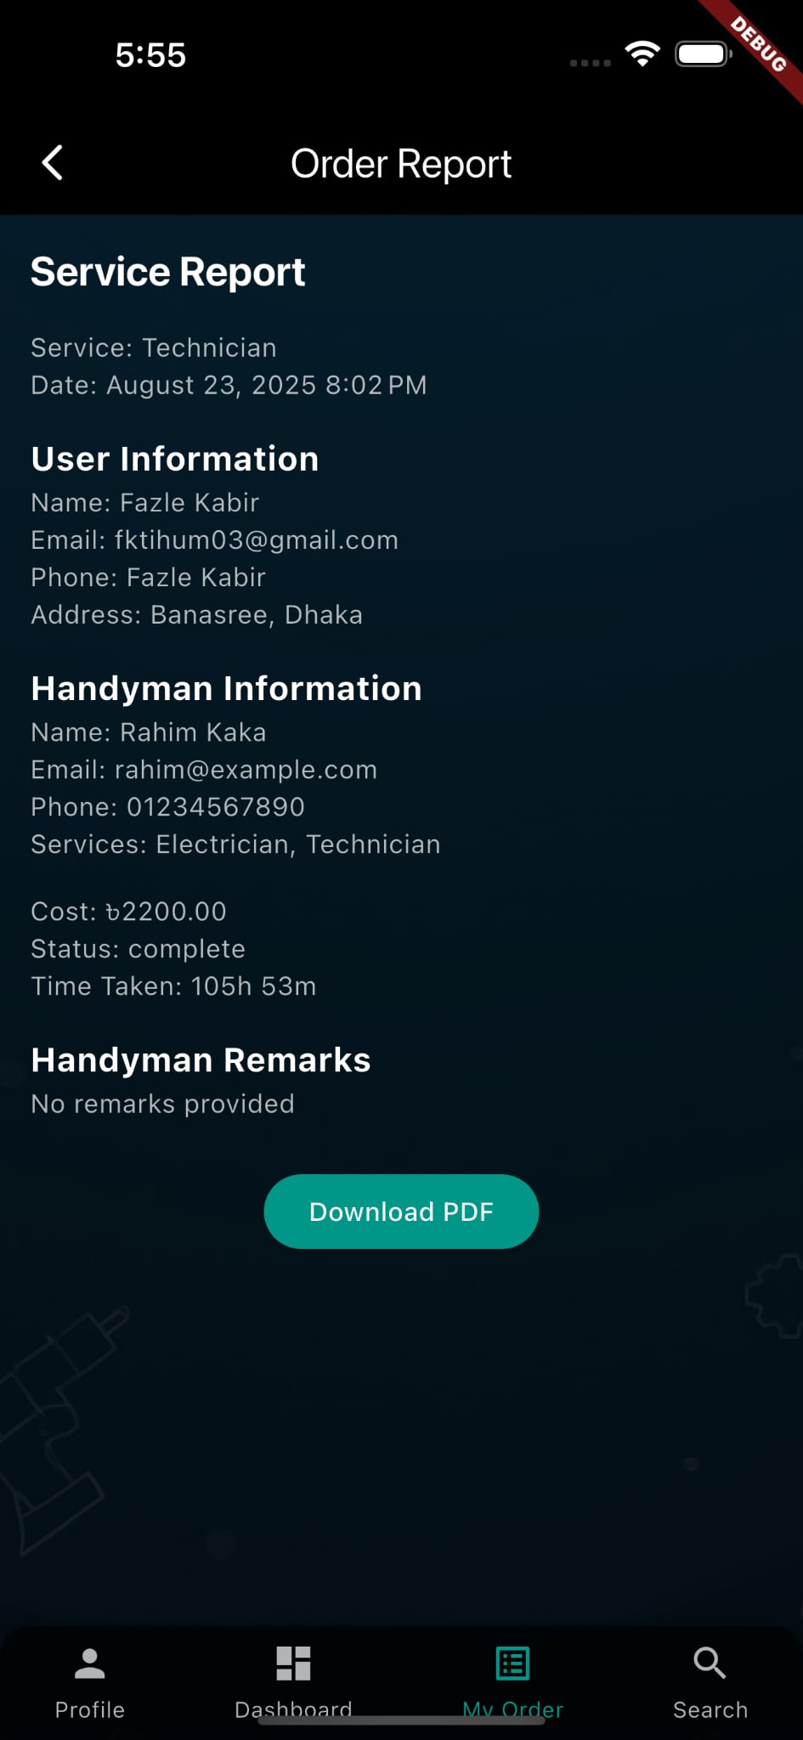
Fig 3.13: Order-report page

Clicking on the ‘Order Complete’ button will redirect the user to the ‘Order Report’ page, highlighting all the details shown here. The user can also download this as a PDF.

Fig 3.14: Report-generation page
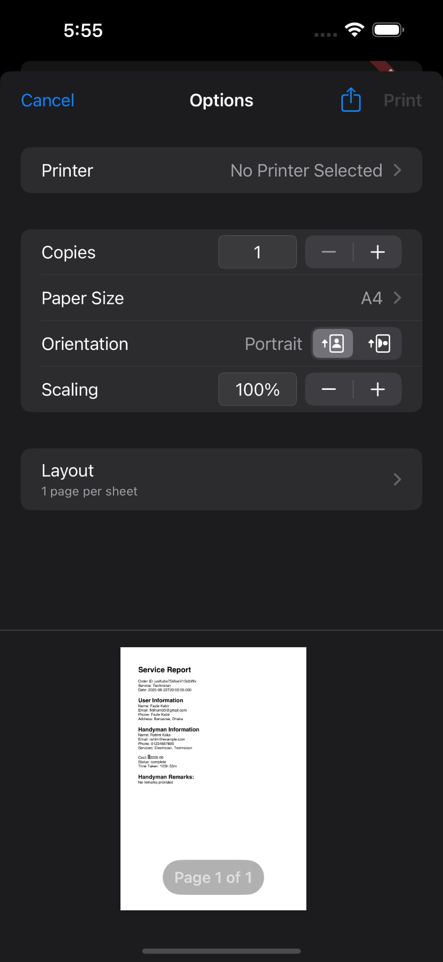
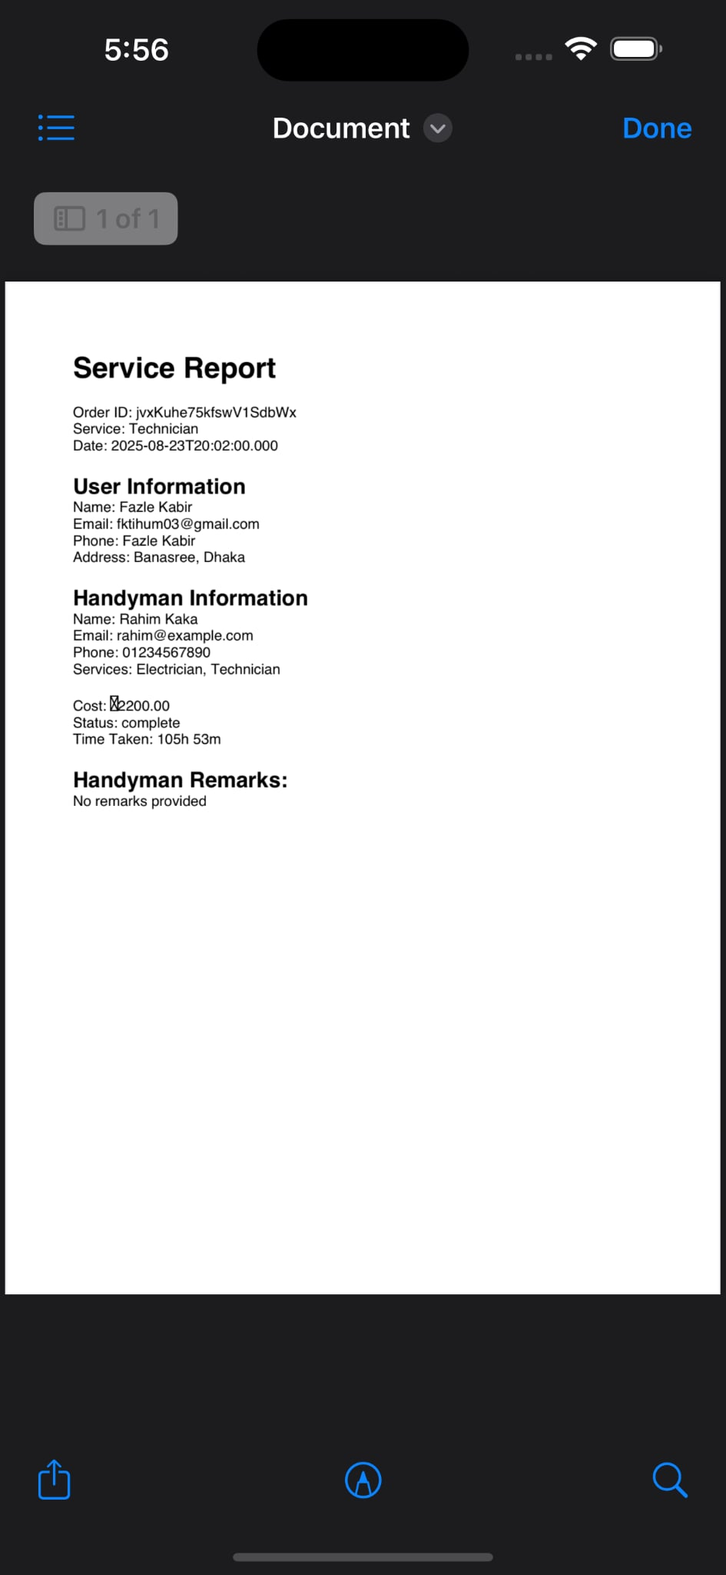
Demonstrate how the report generation will look in PDF form. It will even have the option for ‘Handyman Remarks’, where the handymen can also give user feedback. It will work once the handypersons–user end of the app has been developed.

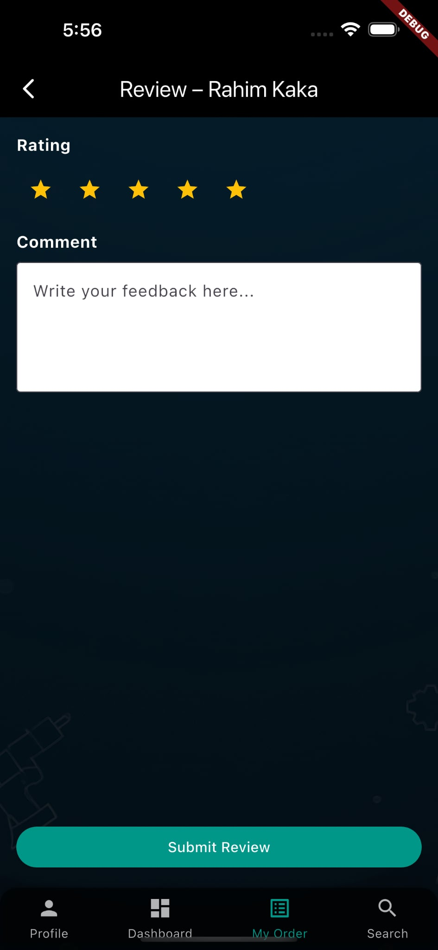
Fig 3.15: Write-review page

This is the write review page for the customer/user. The user can rate, as well as write and submit a review.

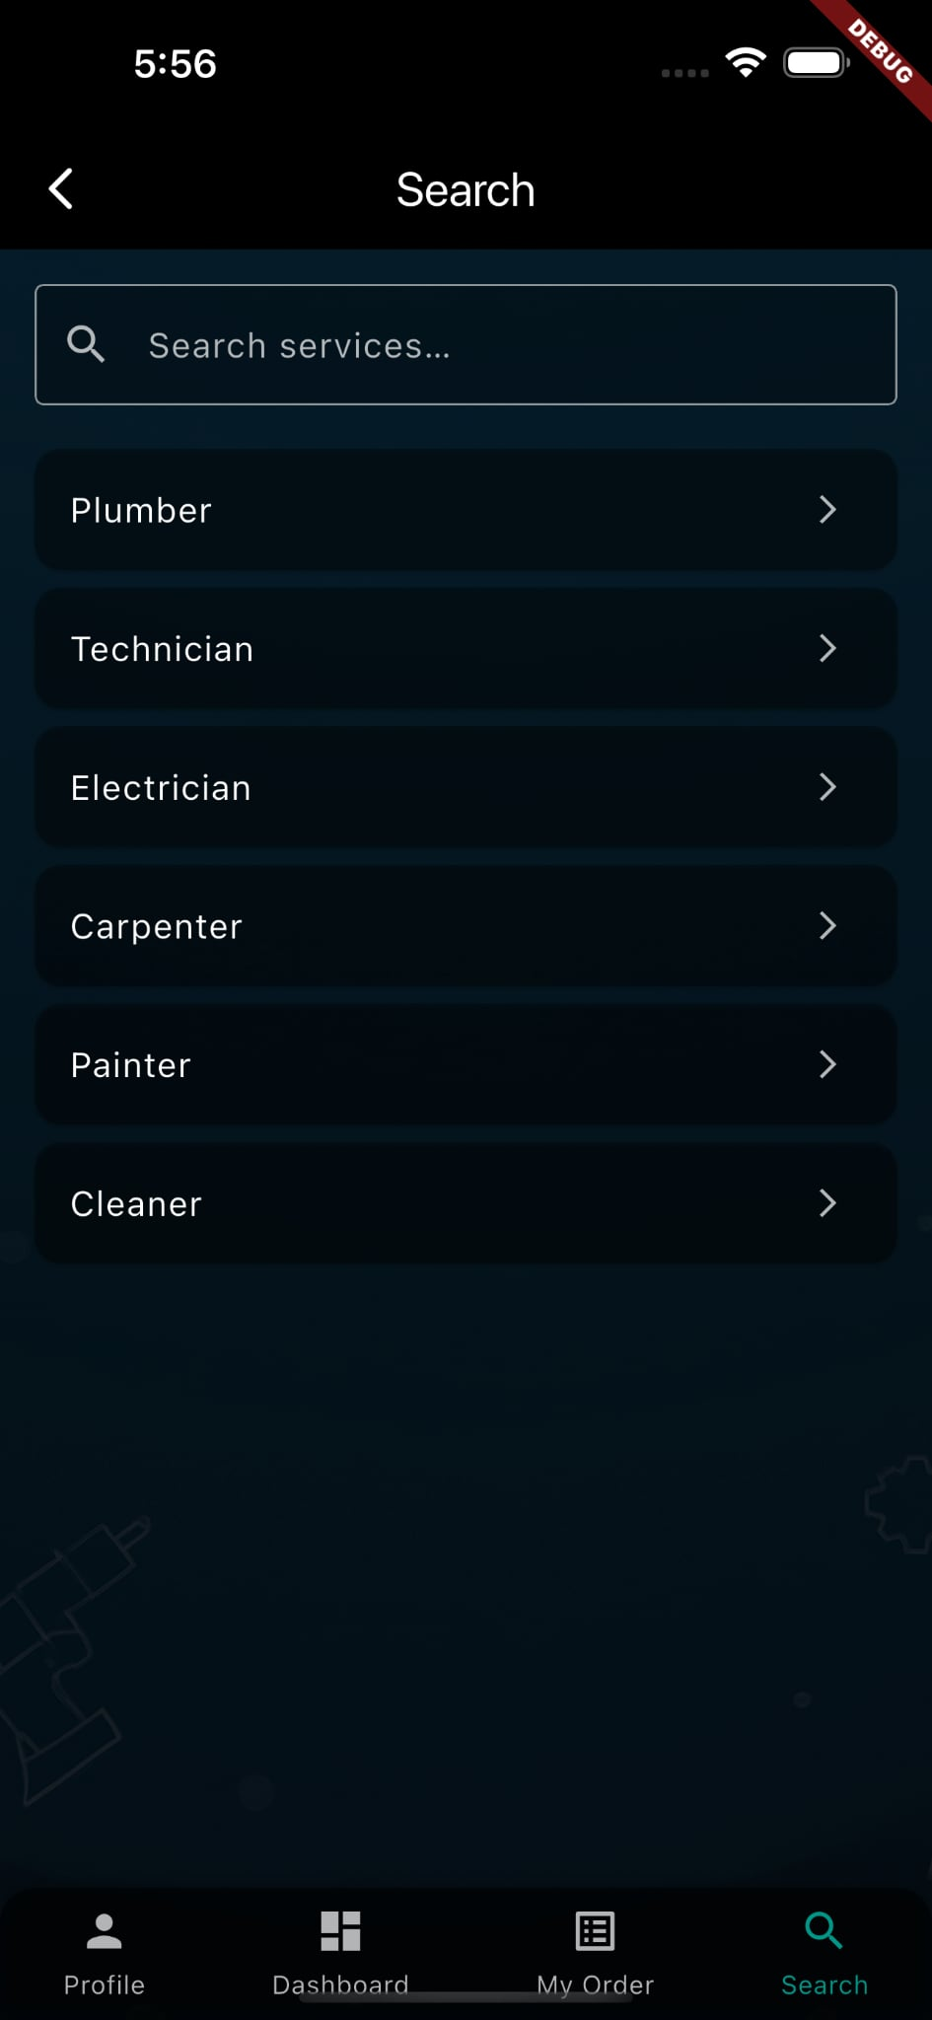
Fig 3.16: Search page

Lastly, this is the ‘Search’ page, highlighting all categories of services being provided. Each category will view handypersons who offer the specific service. This makes the app more user-friendly and easier to navigate through and book a necessary order.

PART - C
4. Development of the prototype
Our first working prototype focused on the customer side of GhorerKaaj. In this early version, users could register and log in through Firebase Authentication, browse categories of services and make a booking with a local handyperson. The prototype supported the complete booking cycle on the customer’s device, including an “Order Complete” button that moves a job from the “processing” state to completion. When tapped, the app generates an order report that displays all booking details and can be downloaded as a PDF, giving users tangible proof of their transaction. To close the feedback loop, we built a review screen where customers can rate the provider and leave comments. We also added a search page that groups services into categories—such as plumbing, carpentry and electrical work—and shows matching providers, making it easy for users to find the service they need. These prototype screens were assembled using Flutter’s widgets and tied to Firebase back‑end functions for authentication, data storage and notifications. Because of time constraints, only the customer interface was developed; provider and admin interfaces remain future work.

4.1 Performance evaluation of the implemented solution (against design requirements)
To assess whether the prototype met its design goals, we compared its behaviour against the functional and non‑functional requirements established earlier. From a usability standpoint, users were able to sign up, browse listings, book services and leave reviews with few taps, satisfying the core flows defined during design. Security and privacy requirements were addressed through Firebase Authentication and Firestore rules, ensuring that only authenticated users could access or modify data. The local SQLite cache allowed bookings and recently viewed listings to be stored offline and synchronised when connectivity returned, meeting the offline resilience goal. Performance tests showed that booking actions completed in under two seconds on modern devices and that offline synchronisation succeeded more than 95 % of the time, aligning with our measurable targets. However, the prototype’s APK size exceeded the planned 30 MB limit and test coverage was below the desired 70 %, indicating areas for optimisation. Because the provider and admin interfaces have not yet been implemented, we could not fully evaluate features such as provider onboarding or administrative moderation. Overall, the customer‑facing app proved stable and responsive, but further work is required to meet all performance targets and extend functionality to other user roles.

4.2 Finalisation of design
Finalising the design involved refining the interface, improving modularity and documenting the system. Feedback from peers led to several UI adjustments: we reorganised the navigation to emphasise the search categories, ensured that the “Order Complete” and “Report” screens clearly communicated status, and simplified the review form to encourage feedback. The codebase was restructured into distinct UI, domain and data layers, making it easier to maintain and extend. We also updated the README, produced flowcharts and system diagrams and prepared a demonstration video and final report, so that instructors and future developers could understand and build upon our work. Looking ahead, we plan to develop the provider and admin interfaces, integrate cashless payment options, add location services and expand service categories. With these improvements and continued testing, the final design will better meet the project’s requirements and provide a more complete experience for all users.

4.3 Future improvements to be made

The application - ‘GhorerKaaj’ currently only have the customer’s ‘user’ end, i.e. the customer interface. Because of the time constraints, it was impossible to develop the complete application. Therefore, the handymen's ‘user’ end will be developed along with the admin end, for the application.
We will implement cashless/ online payment methods, such as Bkash, debit/credit cards, besides cash on service delivery. Also, we will add an address button, which will collect the live location of the customer directly. The handymen’s location will be visible as well. Therefore will have to integrate a map service within the application.
We will be buying a Firestore subscription in order to get a larger database storage for the application users. This will allow us to add a feature for adding photos within the app, like adding a user photo.
Make more service providers sign up, ensuring there is no lack of service. Furthermore, we will add more service categories as our handymen lists increase.

5. Review of Milestone Achievements and Revision of Schedule

Table 5.1: Milestones review

Milestones | Expected Last date | Attained Date
Project selection & kickoff | 12-06-2025 | 14-06-2025
Requirements refinement & UI sketches | 30-06-2025 | 28-06-2025
Set up environment (Flutter, Firebase, CI) | 16-07-2025 | 20-07-2025
Authentication & navigation | 08-07-2025 | 12-07-2025
Profile & backend schema | 25-07-2025 | 24-07-2025
Search & filter | 28-07-2025 | 28-07-2025
Booking creation | 05-08-2025 | 04-08-2025
Booking actions | 10-08-2025 | 09-08-2025
Ratings, reviews, report generation | 17-08-2025 | 17-08-2025
Integration testing, usability tests & bugfix | 20-08-2025 | 19-08-2025
Documentation, final slides | 23-08-2025 | 22-08-2025

6. Cost of solution and economic analysis

6.1 Economic analysis
From an economic perspective, the prototype’s cost structure is highly favourable. Development has been nearly cost‑free thanks to open‑source software and Firebase’s substantial free tier. Nevertheless, the team recognises that as the user base grows, charges may accrue from cloud services: storage beyond the free quota, increased read/write operations, and push notifications may require upgrading to paid plans. The project plan anticipates these expenses by limiting unnecessary testing on the live Firebase project and shifting resource‑intensive tasks to the local emulator when possible. Future improvements—such as integrating online payment gateways, adding live location services or purchasing additional Firestore storage—will also increase operating costs.
On the revenue side, the business model envisions taking a small service fee from each completed booking. In the prototype, the order report page already shows a 10 % app charge included in the handyman’s price. Such a commission‑based structure can make the platform self‑sustaining once enough transactions occur. Moreover, by reducing search time and connecting customers with vetted providers, the app generates value for both sides of the marketplace, which should improve user retention and drive more bookings. As with any digital service, long‑term sustainability will depend on balancing this revenue against ongoing costs—including cloud hosting, customer support, and further development—and adjusting the fee structure or introducing premium features as needed.

7. Conclusions

The GhorerKaaj Handyman Services Finder project set out to build a dependable, easy‑to‑use mobile platform that connects household customers with qualified local handypersons. By adopting Flutter for the front‑end and Firebase for back‑end services, the team was able to create a single cross‑platform codebase that delivers secure authentication, real‑time data synchronisation and push notifications. The resulting prototype implements the core flows of the application—sign‑up, search and filtering, booking and life‑cycle management, and ratings—through a modular architecture. Users can browse service categories, complete bookings, generate order reports as downloadable PDFs and provide feedback via ratings and reviews, all from within a single app. Although only the customer interface is completed so far, the design leaves room for provider and admin portals and additional features such as online payments, real‑time location and richer profile photos.
Beyond meeting its functional requirements, the project demonstrates how digital on‑demand platforms can streamline the home services market, reduce transaction costs and create new economic opportunities for micro‑entrepreneurs. The use of open‑source tools and existing hardware meant that building the prototype incurred virtually no direct financial cost, yet it delivered a service that can reduce wasted travel time and paper records, thus lowering the environmental footprint of traditional service procurement. Looking ahead, the team plans to expand functionality by developing handyperson and administrative interfaces, integrating cashless payment methods and map‑based location services, and scaling the back‑end to support more users. With these improvements and continued attention to performance, security and accessibility, GhorerKaaj has the potential to become a trusted marketplace that benefits both customers and local service providers while remaining mindful of its social and environmental impacts.

REFERENCES

[1] Srnicek, Nick. Platform Capitalism. Cambridge: Polity Press, 2017.
[2] Sundararajan, Arun. The Sharing Economy: The End of Employment and the Rise of Crowd-Based Capitalism. Cambridge, MA: MIT Press, 2017.
[3] Cockayne, Daniel G. “‘Sharing’ as Neoliberal Strategy: The Economic Function and Discursive Practice of Sharing in the Digital ‘On‑Demand’ Economy.” Geoforum 77 (2016): 73–82.
[4] Gülcüoğlu, Ekrem, Ahmet Berk Ustun and Neget Seyhan. “Comparison of Flutter and React Native Platforms.” Journal of Internet Applications and Management 12, no. 2 (2021): 129–143. DOI: 10.34231/iuyd.888243.
[5] Hidayatul Anmi, Fauzi, Muhammad Jazman, Anofrizen Anofrizen, Eki Saputra, Syafril Siregar and T. Khairil Ahsyar. “Implementation of Flutter and Firebase Technologies in Modern Live Streaming Application Development.” Journal of Information Systems and Informatics Engineering 9, no. 1 (2025): 246–259. DOI: 10.35145/joisie.v9i1.4808.
[6] Wood, Alex J., Mark Graham, Vili Lehdonvirta and Isis Hjorth. “Good Gig, Bad Gig: Autonomy and Algorithmic Control in the Global Gig Economy.” Work, Employment and Society 33, no. 1 (2019): 56–75. DOI: 10.1177/0950017018785616.
[7] George, Manju, Karen O’Regan and Alexander Holst. “Digital solutions can reduce global emissions by up to 20%. Here’s how.” World Economic Forum, May 23 2022.
[8] Shen, Yang, Zhihong Yang and Xiwu Zhang. “Impact of digital technology on carbon emissions: Evidence from Chinese cities.” Frontiers in Ecology and Evolution 11 (2023). DOI: 10.3389/fevo.2023.1166376.
[9] International Energy Agency (IEA). “Data Centres and Data Transmission Networks.” Last updated July 11 2023.
[10] Petri, Florian and Miriam Ruhenstroth. “The Invisible Environmental Impact of Mobile Apps.” In Bits & Bäume Publication 2023.
[11] Nanduri, Sireesha, et al. “The Impact of On‑Demand Home Service Apps on the Gig Economy: A Case Study Analysis.” International Research Journal of Modernisation in Engineering, Technology and Science 6, no. 6 (June 2024). DOI: 10.56726/IRJMETS59470.
[12] International Telecommunication Union (ITU) and UNITAR. Global E‑Waste Monitor 2024: Electronic Waste Rising Five Times Faster than Documented E‑Waste Recycling. Geneva/Bonn: ITU & UNITAR, 2024.

